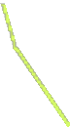

PRODUCT DESIGN

& DEVELOPMENT LAB

MATHCAD

STUDENT MANUAL

**PRODUCT DESIGN AND DEVELOPMENT LABORATORY**

This lab allows you to visualize your imagination in a virtual environment and which can be further developed and optimized. PTC Creo software package is used to achieve this and which helps you to save time, money and effort to develop new concepts and bring them into reality. In any design cycle, product design and development is the critical stage to bring life to any conceptual model.



IDEA

TESTING

DEFINE

DESIGN &

DEVELOPMENT

PROTOTYPE

CONCEPT

DEVELOP

In this lab you will be learning basic modelling of parts (solids, sheet metals and Class – A surfaces), Assembly, Drafting, creating of different tools and dies for manufacturing special parts and also MathCAD to create report of your mathematical calculations related to your design.

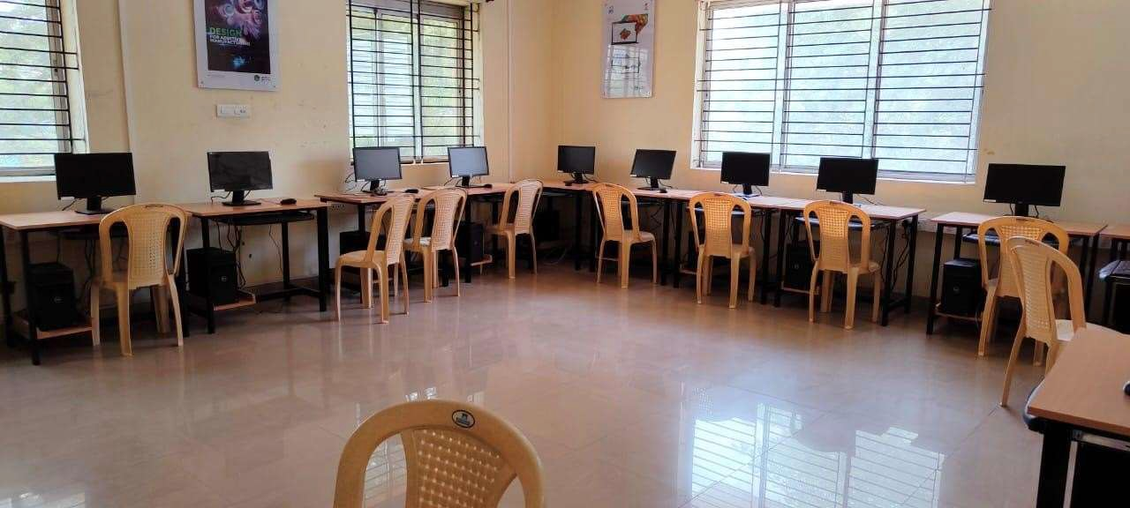The list of courses offered,

|  |  |  |
| --- | --- | --- |
| **S. No** | **Name of the Course** | **Duration** |
| 1 | Creo for Design | 108 Hours |
| 2 | Creo for Industrial Engineers | 72 Hours |
| 3 | Specialization program for Tool and Die design | 40 Hours |
| 4 | MathCAD | 40 Hours |

**CREO FOR MATH CAD**

**MATHCAD**

Mathcad course is designed for users who are new to use CAD tools to solve engineering mathematics. This course will introduce users to Getting started to Mathcad, Documentation and formatting, Entering and editing math, using Mathematical functions and variables. The users will equip the skill to use mathematical expressions like Vectors and Matrices, formulas, Boolean expressions to solve maths within Creo Mathcad sheet.

|  |  |  |
| --- | --- | --- |
| **S. No** | **Name of the Course** | **Duration** |
| 1 | MathCAD | 40 Hours |

## SOFTWARE PACKAGE:

PTC MathCAD Prime 6.0.0.0

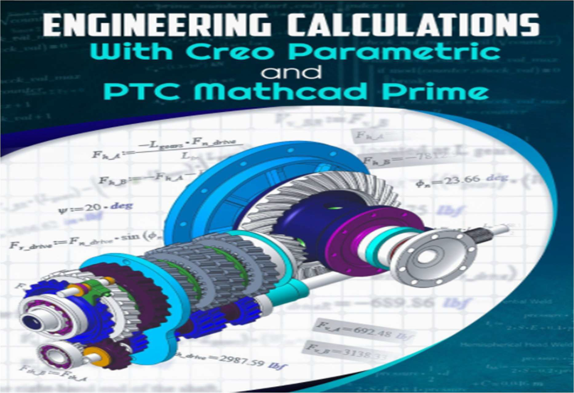

**TABLE OF CONTENTS**

CHAPTER 1 – GETTING STARTED 01-04

Opening Mathcad 01

The Mathcad Workspace 02

Saving Mathcad Files 03

CHAPTER 2 – DOCUMENTING AND FORMATTING 05-08

Text Regions 05

Locally modify text 06

Embedding Math in a Text Region 06

Options for Formatting Worksheets 07

Understanding Mathcad Templates 07

CHAPTER 3 – ENTERING AND EDITING MATH 09-14

To insert an operator 09

To identify operands 10

To modify an operator 10

To create a mathematical expression 11

To evaluate the mathematical expression 12

Formatting Math Regions 12

Globally format math styles 12

To highlight a region 13

CHAPTER 4 – VARIABLES 15-18

To Define a variable 15

To numerically evaluate a variable in Mathcad 16

To Define a global variable 17

To evaluate the global variable 17

To retroactively assign an expression 17

To create a variable containing a literal subscript 18

CHAPTER 5 – FUNCTIONS 19-22

To define a user-defined function 19

To Insert and evaluate a built-in function 20

CHAPTER 6 – RANGE VARIABLES 23-25

To define a range variable with a constant step size 23

To Define a range variable with a unit step size 24

To evaluate a range variable 24

To Use a range variable in a function calculation 25

CHAPTER 7 – CONTROLLING CALCULATIONS 26-30

To Disable Automatic Calculation mode 26

To disable math regions 27

To Re-enable math regions 27

To insert an area 29

To Collapse and protect the area 29

To Unprotect and expand the area 30

To delete the area 30

CHAPTER 8 – VECTORS AND MATRICES 31-39

To globally change the array ORIGIN 31

To locally change the array ORIGIN 32

To define a vector or matrix manually 33

To Define a vector or matrix element-by-element 33

To Define a vector or matrix using range variables 34

To extract a single element from an array 35

To extract a column from an array 36

To extract a row from an array 36

To extract a subset of data from an array 36

To Display nested array elements by extracting the array 38

To Display nested array elements by specifying the result format 38

To Use the Vectorization operator 39

CHAPTER 9 – UNITS 40-46

To add units to variable definitions 40

To Change units 41

To define a custom unit 41

To add units to an entire array 42

To add units to each element of an array 43

To add units to a range variable 43

To define variables using degrees Celsius or Fahrenheit 44

Convert temperatures to Celsius or Fahrenheit from degrees Kelvin or Rankine 45

To evaluate temperature differences 45

CHAPTER 10 – 2-D PLOTTING 47-59

To Plot data on a 2-D graph 47

To Format the plot to display individual data points 48

To Plot a function using a defined independent variable 50

To manually edit the axis limits 51

To Plot a function using a quick plot 52

To add markers to the plot 53

* 1. Trace Formatting 54

To Format a trace 55

To add additional traces to a plot 56

To edit the tick mark value on the x-axis 57

To Plot a 2-D plot 58

To Change the plot units 59

CHAPTER 11 – 3-D PLOTTING 60-68

To Plot a function in three dimensions 60

To Change the plot domain 61

To Change the default domain to not include any values that cause a singularity in the plotted function 63

To Plot a three column matrix 65

To Plot data using an m x n matrix 66

To Plot multiple traces on a single plot 67

To Format the traces 68

CHAPTER 12 – BOOLEAN CONDITIONS 69-71

To create Piecewise Continuous functions using Boolean operators 70

To define the range and function to use in the Piecewise Continuous function 70

CHAPTER 13 – SYMBOLICS 72-73

To evaluate a result symbolically 72

CHAPTER 14 – SOLVING 74-83

To utilize the root function, two-argument case 75

To utilize the root function, four-argument case 76

To utilize the poly-roots function 76

To symbolically solve the roots. 77

To Use the built-in lsolve function to solve the system of equations 78

To Use a solve block to solve the system of equations 79

To Use a solve block to solve the system of nonlinear equations 81

To Solve a system of equations symbolically 82

CHAPTER 15 – PROGRAMMING 84-94

To start a program in Mathcad 84

To assign a local definition 84

To End a program in Mathcad 86

To evaluate a program in Mathcad 86

To Use the if programming operator 87

To Use the else programming operator 89

To Use a for loop to program the Fibonacci series 91

To Use a while loop to Newton's method for finding the root of a number 93

# CHAPTER 1 - GETTING STARTED

## OPENING MATHCAD

Click Start > PTC Mathcad Prime 6.0.0.0 Mathcad opens and displays a blank worksheet.

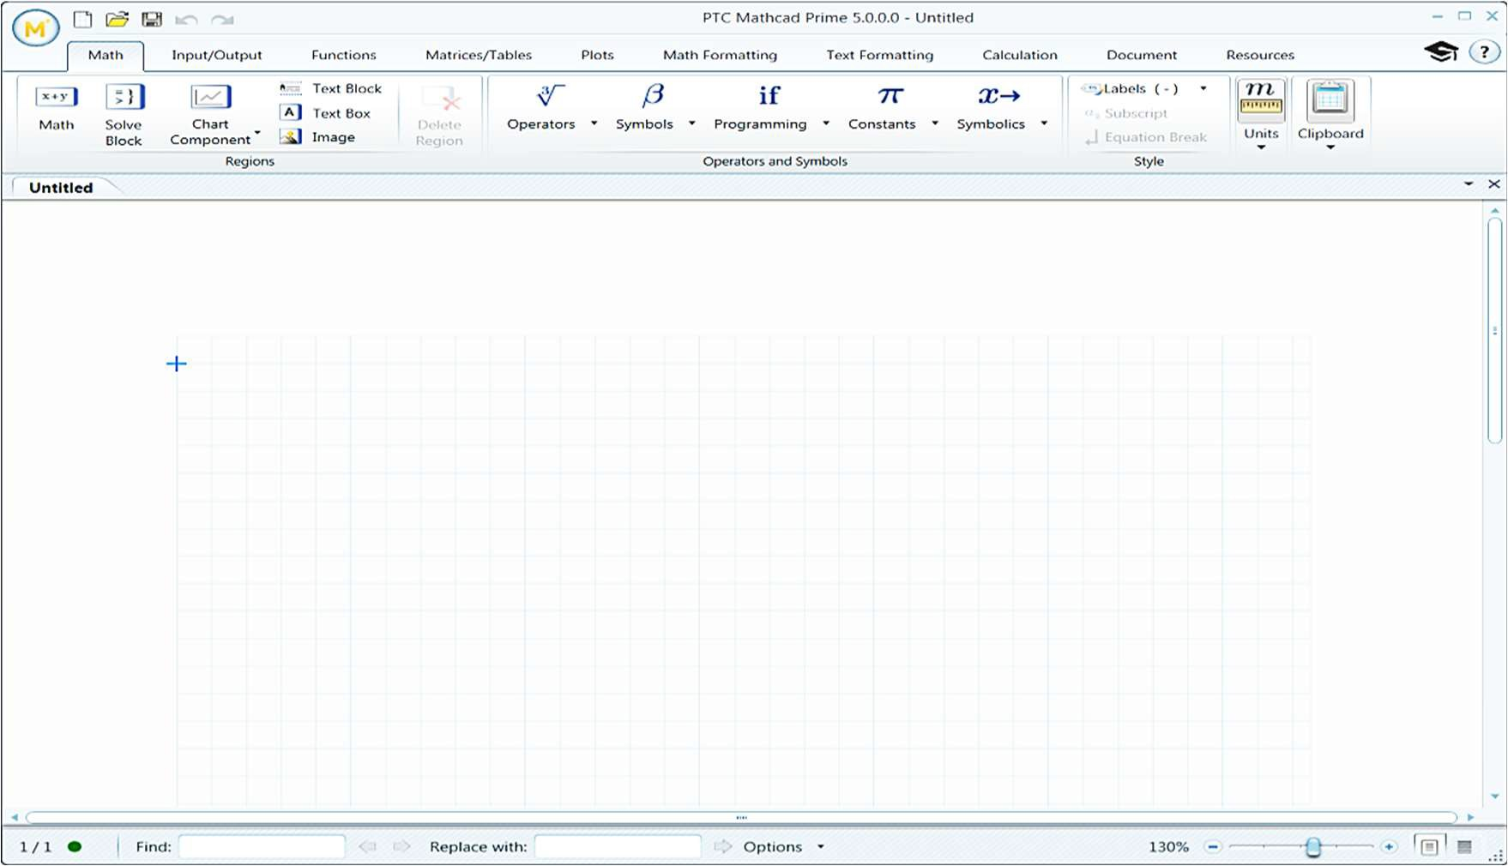

### Create new mathcad file:

Click the Prime  button > New > New Worksheet

### Open an existing Mathcad file:

Click the Prime button and click Open.

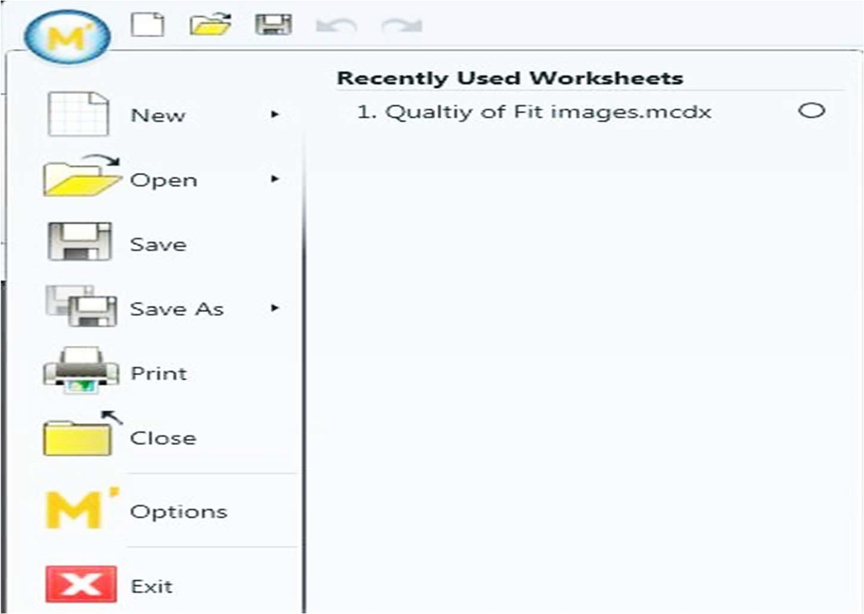

## THE MATHCAD WORKSPACE

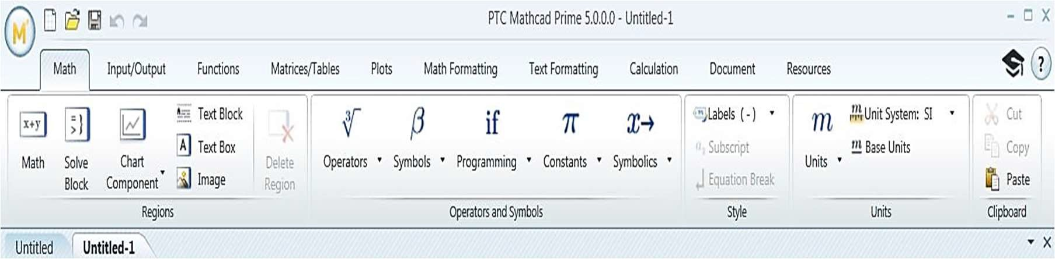

Figure 1 – The Mathcad Workspace

The Mathcad workspace consists of worksheets and the following user interface items:

* The Mathcad Prime button – When selected, you can access commands, such as Open, Save, and Print, which are related to files.
* Ribbon – The ribbon contains tabs that have group-related commands. The following tabs are available:
* Math – Contains operators, symbols, constants, and units.
* Input/Output – Contains data input and output elements.
* Functions – Contains Mathcad built-in functions.
* Matrices/Tables – Contains matrices, table operators, and functions.
* Plots – Contains commands to insert and format plots.
* Math Formatting – Contains math, results, and label- formatting commands.
* Text Formatting – Contains text and paragraph- formatting commands
* Calculation – Contains calculation options, controls, and error tracing.
* Document – Contains documentation and page options.
* Resources – Contains help, tutorials, and various other supporting resources.

### Quick Access toolbar:

Contains frequently used commands. By default, the New, Open, Save, Undo, and Redo commands are located here. You can customize this by right-clicking a command or icon located in the ribbon and selecting Add to Quick Access Toolbar.

### Status Bar:

Located at the bottom of the Mathcad window and contains:

* Find and Replace commands.
* A Zoom Slider.
* Page and Draft View icons.
* Display and calculate your work in Mathcad worksheets.

Math, text, and other elements are contained in regions in your worksheet. The following types of regions are available:

* Math
* Table
* Plot
* Solve Block
* Image
* Text Block or Box

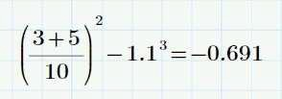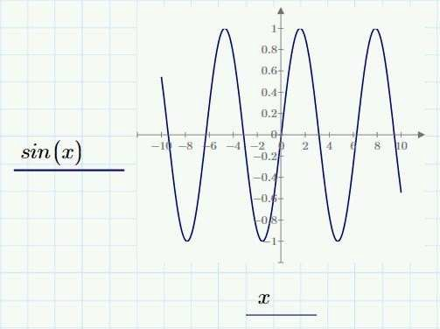

Figure 2- Math Region Figure 3 – Plot Region

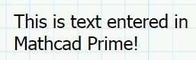

Figure 4 – Text Region

## SAVING MATHCAD FILES

To save a Mathcad file, select one of the following to save as

* MCDX: The default save format for Mathcad files is a Mathcad MCDX document (.mcdx).
* MCTX: You can save your document as a template that can be used to create future worksheets.
* RTF: You can save your document in the Rich Text format.
* XPS: You can also select an XML Paper Specification format (.xps). The XPS format is Microsoft’s electronic paper file format and is similar to a PDF.

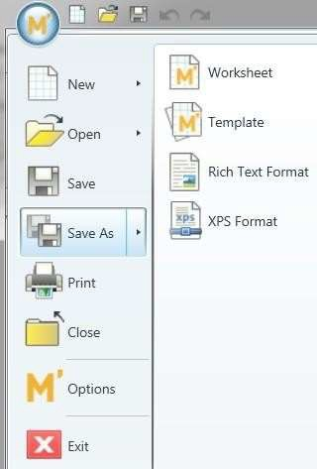

Figure 5 – Selecting a File Type from Save As

# CHAPTER 2 – DOCUMENTING AND FORMATTING

## TEXT REGIONS

Mathcad supports calculation documentation through the use of text regions. Text regions are text blocks or text boxes contain resize handles.



Figure 1 – Text Region

Have a text style that you can view on the Text Formatting tab which determines:

* Font
* Size
* Color
* Other standard text properties

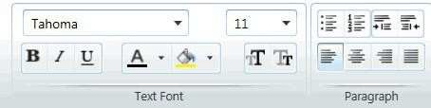

Figure 2 – Text Formatting Tab

You can insert a text region by selecting the Document or Math tabs. You can also utilize these additional methods to insert text:

* A text block by pressing CTRL+SHIFT+T.
* A text box by pressing CTRL+T.

A text block is a text region that extends the full page width and does not overlap with other regions in the worksheet. A text box is a text region that expands as text is typed and can be moved across the worksheet. Text boxes contain a resize handle to control the width of the region.

### Text Regions Style:

Each text region has an associated text style. A style determines the font, size, color, and other standard text properties. The current text style displays in the Text Font group of the Text Formatting tab. You can change the text style globally or locally.

### The Formatting tab also enables you to:

Alter justification.

Add bullets or numbers to lists. Decrease or increase font size. Locally modify text.

Globally modify text.

Select the Text Formatting tab.

In the Text Font group, click the Font drop-down list and select a font.

In the Text Font group, click the Font Size drop-down list and select a size.

## LOCALLY MODIFY TEXT:



* + 1. Click in a blank space in the worksheet and press CTRL+T to insert a text box.
    2. Click in the text box and type Formatting text in Mathcad Prime.
    3. Highlight the word Mathcad in the text region.
    4. Select the Text Formatting tab.
    5. In the Font group, make all desired changes.
    6. This completes the procedure.

## EMBEDDING MATH IN A TEXT REGION

You can insert a math region in a text block or a text box. You can embed:

* Expressions
* Definitions
* Functions
* Matrices

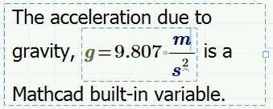

1. Click in a blank space in the worksheet. Right-click and select Insert Text Box from the context menu.
2. In the text box, type “The acceleration due to gravity”.
3. Select the Math tab.
4. In the Regions group, click Math Region to embed a math region in the text region.
5. In the math region, type g= to evaluate the acceleration due to gravity (g).
6. In the text box, click outside of the math region and type is a Mathcad built-in variable.
7. Click outside of the text region to complete embedding the math region inside of the text region.

## OPTIONS FOR FORMATTING WORKSHEETS

Mathcad enables you to create readable, aesthetically pleasing worksheets. You can format worksheets using one or more of the following options:

* Inserting and deleting blank lines.
* Separating overlapping regions.
* Displaying grids and adjusting the grid size.
* Editing the worksheet header and footer.
* Moving selected text regions using the arrow keys. Options for Formatting Worksheets

To create readable, aesthetically pleasing worksheets, you can format worksheets using one or more of the following options:

* Insert and delete blank lines by right-clicking a blank area between two regions and selecting Add Space or Remove Space.
* Separate overlapping regions by selecting both regions, right- clicking, and selecting Separate Regions Vertically or Separate Regions Horizontally.
* Toggle the worksheet grid off and on by selecting the Document tab. In the Page group, click Show Grid .
* Adjust the grid size by selecting the Document tab. In the Page group, click Grid Size and select Standard or Fine from the Grid Size drop-down list.
* To edit the header or footer, select the Document tab. In the Headers and Footers group, click Header to edit the worksheet header, or click Footer to edit the worksheet footer. By specifying the commands in the Headers and Footers group, you can:
  + Insert a page number.
  + Insert the last saved date.
  + Insert the file name or the full file path.

To move a math or text region, select it and use the arrow keys on your keyboard.

## UNDERSTANDING MATHCAD TEMPLATES

Templates are an important aspect of calculation management within an organization. You can have multiple templates: a single corporate standard or separate templates for a variety of tasks that need to be standardized. Templates have the extension .mctx and are identical in form to a .mcdx worksheet.

Mathcad templates can specify the following:

* Math styles – Available on the Math Formatting tab.
* Text styles – Available on the Text Formatting tab.
* Page defaults – Available on the Document tab.
* Headers and footers – Available on the Document tab.
* Numerical formats – Available on the Math Formatting tab.
* Unit systems – Available on the Math tab.
* Calculation mode – Available on the Calculation tab.
* Plot values: available on the Plot tab

Templates are often starting points for new worksheets in which all document settings have been established. Your personal templates are stored in the My Templates folder. You can also share your templates by saving them to the Shared Templates folder.

To use a Mathcad template, click Prime select New, and select one of the following options:

* From My Templates
* From Shared Templates
* From Default Templates

Alternately, you can select a template from the Recently Used Templates section.

Once your new worksheet has been created using the template, save your worksheet as a

.mcdx file using a new file name.

# CHAPTER 3-ENTERING AND EDITING MATH

## USING OPERATORS

Operators are symbols, such as the plus sign (+) and the minus sign (-), that link variables and numbers together to form expressions.

## TO INSERT AN OPERATOR:

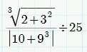

* Click in the worksheet and insert the Square Root and Nth Root operator.
* Select the Math tab.
* In the Operators and Symbols group, click Operators
* Select the Square Root and Nth Root operator.

Note: All operators in this procedure are accessed by selecting the Math tab, clicking Operators, and selecting the desired operator.

* Type 2+3 in the placeholder under the Square Root operator. The cursor appears to the right of the 3 when complete.
* Insert the Exponentiation operator. Type 2 in the placeholder that appears.
* Click in the placeholder for the Nth Root and type 3.
* Press SPACEBAR until the entire expression is highlighted. Insert the Division operator.
* Click in the denominator placeholder and insert the Absolute Value or Determinant operator. Type 10+9 in the placeholder. The cursor appears to the right of the 9 when complete.
* Insert the Exponentiation operator. Type 3 in the placeholder that appears.
* Press SPACEBAR until the entire expression is highlighted. Insert the Inline
* Division operator.
* Type 25 in the placeholder that appears.
* Click outside of the region to complete.

Note: An alternate method of inserting an operator is to use the keystroke shown in the tooltip for the operator.

## TO IDENTIFY OPERANDS.

* Using the expression typed in for the previous task, click any operator.
* Note that the operator color changes to blue and blinks. The operands associated with the blue highlighted operator highlight in gray.
* Click other operators and note how the operands change.

## TO MODIFY AN OPERATOR:

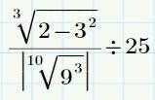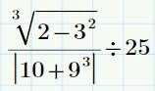

* Using the expression typed in for Task 1,
* Click the + operator in the numerator.
* Type - and click outside of the expression.
* Using the modified expression, click the + operator in the denominator.
* Insert the Square Root and Nth Root operator.

Note the operand location.

## ENTERING AND EVALUATING A MATHEMATICAL EXPRESSION

A mathematical expression in Mathcad is typed in a Math region using natural math notation.

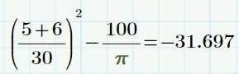

Figure 1: Evaluated Mathematical Expression

You can use the following item to insert and evaluate mathematical expressions:

* Placeholders
* Operators
* Symbols
* Constants

### Placeholders

Placeholders appear whenever you apply an operator. In the placeholder, you can type a constant, variable, or another expression. If you do not fill in the placeholder, an error message appears when you click outside of the region.

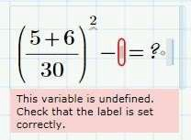

Placeholders also display when you insert constructs such as integrals, derivatives, and summations. You can type an appropriate number, variable, or expression in each placeholder. To navigate to each placeholder, you can use one of the following methods:

* Click in each placeholder individually.
* Press the arrow keys.

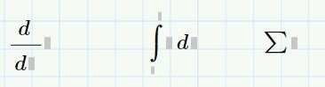

## TO CREATE A MATHEMATICAL EXPRESSION.

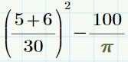

* Click in the worksheet and type the term shown.

**Note:** Insert operators by selecting the Math tab. In the Operators and Symbols group, click Operators, and select the desired operator.

* Select the entire term. Place the cursor on the right side of the term. Press – (the minus symbol) and type 100 in the placeholder.
* Insert the Division operator.
* Insert the Pi constant.
* Select the Math tab.
* In the Operators and Symbols group, click Constants.
* Select Pi .

**Note:** Pi displays in a different color. This denotes that Pi is labeled as a constant.

## TO EVALUATE THE MATHEMATICAL EXPRESSION.

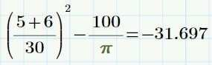

* Click anywhere in the expression you created in the previous task.
* Press = (equal sign

**Note:** You can also insert the Evaluation operator by selecting the Math Tab, Clicking Operators and selecting Evaluation

## FORMATTING MATH REGIONS

Formatting can be applied to all math regions in a worksheet or in selected regions. Each math region has a math font style associated with variables and constants. A style determines the font, size, color, and other standard text properties. You can view the style you are using in a math region in the Math Font group on the Math tab when the region is selected.

Formatting math regions can include:

* Math font properties.
* Label styles.

You can also add highlighting to a math region. This is an effective method for drawing attention to a region or a set of regions.

Each region, math or text, is an individual entity that you can move or position within a workspace. You can move these regions individually or as a group.

## GLOBALLY FORMAT MATH STYLES.

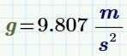

* Click in the worksheet, type g=, and click outside of the region.
* The built-in variable g is evaluated as shown.
* Select the Math Formatting tab.
* In the Label Styles group, select Constant from the Label Styles drop-down menu.
* Select the color red from the color options. The built-in variable name g changes to a red font as shown.
* In the Label Styles group, click Restore Label Style to restore the labels to the default style.

## TO HIGHLIGHT A REGION

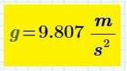

* Click inside the math region created previously, evaluating g.
* Select the math formatting tab.
* In the math font group click Highlight color and select color yellow from the color option.

The region is highlighted as shown.

## FORMATTING MATHEMATICAL RESULTS

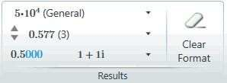

You can apply results formatting globally or to one or more regions in your worksheet. The following formatting options are available:

* Result Format – You can select the display format of numeric results from this drop-down list. The following options are available:
  + General
  + Decimal
  + Scientific
  + Engineering Result Group: Math Formatting Tab
  + Percent
* Display Precision – Controls the number of digits displayed to the right of the decimal point.
* To set the zero threshold for your worksheet, set the result format to Decimal and then modify the display precision. Any result smaller than the selected display precision is displayed as zero.
* Show Trailing Zeros – Toggles the display of trailing zeros to the right of the

decimal point. The display precision selected controls the number of trailing zeros displayed.

* Complex Values – Displays the result in Cartesian or Polar form.
* To remove any changes and return to the default result formatting, click Clear Format
* To set the zero threshold for your worksheet, set the result format to Decimal and then modify the display precision. Any result smaller than the selected display precision is displayed as zero.
* Show Trailing Zeros – Toggles the display of trailing zeros to the right of the decimal point. The display precision selected controls the number of trailing zeros displayed.
* Complex Values – Displays the result in Cartesian or Polar form.
* To remove any changes and return to the default result formatting, click Clear Format.
* Implied multiplication:
* Useful when typing expressions.
* Insert by typing a numerical constant followed by a variable.
* Use is not supported with the following variables: – i, j.



# CHAPTER 4 – VARIABLES

## DEFINING A VARIABLE

Often you must define values as variables that you can use in subsequent calculations

To insert definitions, or assignments, select the Math tab. In the Operators and Symbols group, click ∛ and select Definition

A variable may equal a scalar, array, string, or range of values. Variable names in Mathcad may include

* Upper and lowercase letters.
* Digits (0-9).
* Underscore (_) character.
* Symbols.
* Literal subscripts.
* Constants.

The following restrictions apply to variable names:

* Variable names cannot start with a digit.
* All characters must have the same font.
* Mathcad does not distinguish between variable and function names.

### Variable Error Messages

Expressions may contain a variable that has been previously defined to the left or above the location of its current use. Math regions are read and processed left to right, top to bottom. If the variable used in the expression has not been previously defined, an error message displays and the undefined variable is circled in red. Even if more than one variable is undefined, Mathcad flags one variable at a time.

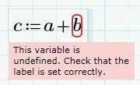

You can overwrite a previous variable definition, built-in variable definition, or function name. If you redefine these names the previous or built-in meaning no longer works.

### To define a variable



* Type a variable name
* Select the Math tab in operators and symbol group click operators and select definition, the definition operator and a placeholder appears.
* Type one of the following place holder
  + A scalar
  + An expression
  + An array
  + A string
  + A range variable

## TO NUMERICALLY EVALUATE A VARIABLE IN MATHCAD.



* To define the variable, type x3. Select the Math tab. In the Operators and Symbols group, click Operators and select Definition.

**Note:** You can also press SHIFT: to insert the **Definition** operator.

* The keystrokes display in the hover text description of the operator.
* Type the expression shown in the placeholder after the Definition operator.

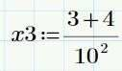

* To evaluate the variable, type x3. Select the Math tab. In the Operators and Symbols group, click Operators and select Evaluation.

You can evaluate a variable:



To the right of where it is defined. Below where it is defined.

You can also evaluate a variable in the definition statement, binding the result to the assigned variable name.

## TO DEFINE A GLOBAL VARIABLE.



* Click in the worksheet and type the variable name global.

**Note:** A global variable name adheres to the same rules and restrictions as a local variable name.

* Select the Math tab.
* Click Operators from the Operators and Symbols group.
* Click Global Definition from the Definition and Evaluation group.
* Type 100 in the placeholder.

**Note:** A global variable definition can contain variables that have been globally defined to the left or above where they are being used.

## TO EVALUATE THE GLOBAL VARIABLE.

* Click the worksheet to the bellow or to the right where you have defined the global variable. Type global
* Press = (equal sign) to evaluate the variable.

**Note:** Once a variable name is used to define a global variable, it cannot be defined in the same worksheet. Any attempt to redefine the name results in an error

## TO RETROACTIVELY ASSIGN AN EXPRESSION.

* Type and evaluate the expression shown.
* Click in the region and place the cursor on the left side of the expression as shown.
* Select the Math tab. In the Operators and Symbols group, click Operators and select Definition. A placeholder appears.
* Type Value in placeholder and click outside of the region. This completes the procedure.

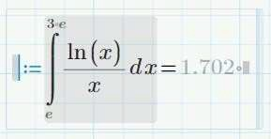

### Using Literal Subscripts

You use literal subscripts in Mathcad for:

* Representing derivatives in partial differential equations.
* You create literal subscripts by selecting the Math tab. In the Style group, click Subscript.

**Note:** Be sure not to confuse literal subscripts with array subscripts. They appear similar, but are different. Literal subscripts represent a variable name. Array subscripts identify an element of an array, specified by the subscript.

## TO CREATE A VARIABLE CONTAINING A LITERAL SUBSCRIPT



* In the blank area of worksheet type v, Select the Math Tab In the Style group, click Subscript. Note the cursor position.
* Type the Subscript text and click outside the math region

# CHAPTER 5 – FUNCTIONS

## DEFINING A USER-DEFINED FUNCTION

A user-defined function is a mathematical expression that provides a unique output for one or more input values. These input values are referred to as the arguments of the function and are always enclosed in a pair of parentheses. Mathcad contains built- in functions and enables the input of user-defined functions.

User-defined function names in Mathcad may include:

* Upper and lowercase letters.
* Digits (0-9).
* Underscore (_) character.
* Symbols.
* Literal subscripts.
* Constants.

The following restrictions apply to user-defined function names:

* Function names cannot start with a digit.
* All characters must have the same font.
* Mathcad does not distinguish between variable and function names.

### Function Error Messages

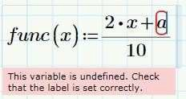

User-defined function expressions may contain a variable that has been previously defined to the left or above the location of its current use. Math regions are read and processed left to right, top to bottom. If the variable used in the expression has not been previously defined, an error message displays and the undefined variable is circled in red. Even if more than one variable is undefined, Mathcad flags one variable at a time. Select the Math tab, In the Operators and you can overwrite a previous variable definition, built-in variable definition, or function name. If you redefine these names, their previous or built-in meaning no longer works.

### To Define a user-defined function:



* Type the function name, func, and press SHIFT+9.
* Type the arguments of the function, x,y, in the placeholder.
* Symbols group, click Operators and select Definition. The Definition operator and a placeholder appears.
* Type the function expression in the placeholder and click outside of the region

### Inserting a Built-In Function

Mathcad provides a library of built-in functions in the following areas:

* Core Mathematical functions.
* Discrete Transform functions.
* Statistics, Probability, and Data Analysis functions.
* Design of Experiments functions.
* Differential Equation Solvers.
* File Access functions.
* Finance functions.
* Image and Signal Processing functions.
* Probability Distribution.
* Solving and Optimization functions.
* Vector and Matrix functions.
* Miscellaneous functions.

To access these functions, select the Functions tab. You can also directly type in a built- in function. Built-in functions are not font sensitive, but they are case sensitive and you must spell them correctly.

## TO INSERT AND EVALUATE A BUILT-IN FUNCTION

* Click in a blank area of the worksheet. Select the Function tab. In the Functions group, click All, the Function dialog box appears left side of the worksheet.
* Expand the Trigonometric function category.

**Note:** You can sort functions in the Functions dialog box by category or by name

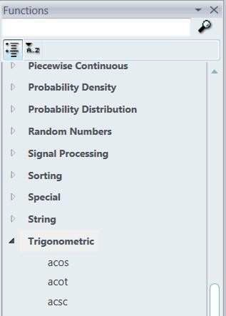

* Select **acos**. This action inserts the function into the worksheet.

**Note:** You can also directly type in a built-in function. Built-in functions are not font sensitive, but they are case sensitive and you must spell them correctly.



* Type 0.5 in the function placeholder and press = (equal sign).

**Note:** To insert a function in the worksheet, select the Functions tab. In the Functions group, click a function category and select the desired function.

This completes the procedure.

### Design of Experiments Functions

Design of Experiments (DOE) functions and plots enable you to analyze the resulting data from experiments performed in a DOE or Robust Design process.

You can use these functions for:

* Constructing experimental design matrices.
* Analyzing and screening factors, and plotting results.
* Developing statistical models.
* Performing Monte Carlo functions

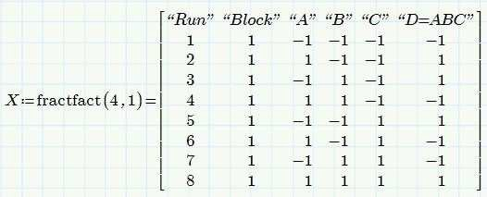 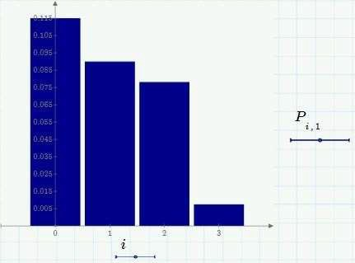

Design of Experiments Functions

Design of Experiments (DOE) functions and plots enable you to analyze the resulting data from experiments performed in a DOE or Robust Design process. You can use these functions for:

* Constructing experimental design matrices.
  + Create, analyze, or modify design matrices using Mathcad’s built-in functions
* Analyzing and screening factors, and plotting results.
  + Screen factors by calculating their effects, level effects, and interactions. Plot experimental results using the plot functionality.
* Developing statistical models.
  + Mathcad DOE functions offer different types of regression analysis.
* Performing Monte Carlo simulations.
  + You can generate random numbers for Monte Carlo simulations as well as create a Monte Carlo sample for a given function.

### Using Deprecated Functions

Deprecated functions are functions that are not available in Mathcad Prime. Deprecated functions:

* Are not documented in Mathcad Prime.
* Work if typed in a worksheet, or imported in a legacy worksheet.
* Are supported by Mathcad Prime for several releases.

Many of the deprecated functions have alternative functions in Mathcad Prime. The Mathcad Prime Help files contains list of the deprecated functions and the existing alternative functions.

# CHAPTER 6 – RANGE VARIABLES

## Defining a Range Variable

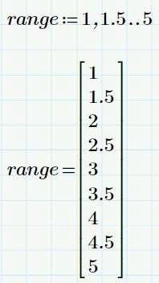

Figure1: A range variable definition

Range variables are variables that are equal to a sequence or range of values. You can use a range value to:

* Iterate a function over a range of values.
* Define a vector or array, element-by-element
* Control the domain of a 2-D plot Every range variable must have
* A starting value.
* An ending value.
* A second value specified, if not using a unit step

## TO DEFINE A RANGE VARIABLE WITH A CONSTANT STEP SIZE.

  

* Click in a blank area of the worksheet and type the variable name force.
* Insert the Definition operator.
  + Select the Math tab.
  + In the Operators and Symbols group, click Operators.
  + Select Definition.

**Note:** You can insert any operator by selecting the Math tab, clicking Operators, and selecting the desired operator

* Type the starting value of the range followed by a comma, 1,.Two placeholders and the Range operator appear.
* Type 1.5 in the first placeholder, and type 5 in the second placeholder.

**Note:** The step size is determined by the difference between the first and second value in the range. The range variable has a constant step size over the entire range.

## TO DEFINE A RANGE VARIABLE WITH A UNIT STEP SIZE.



* Click the blank area of the worksheet and type the variable name force1
* Insert the Definitior. Operator
* Type 1…20 in the placeholder

## TO EVALUATE A RANGE VARIABLE.

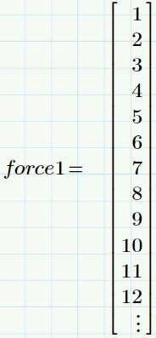

* Click in a blank area of the worksheet, type force1, and press =.
* When evaluating range variables, Mathcad displays the first 12 values in the range. To view the remaining values:
  + Click the three dots in the evaluation display.
  + The navigator window appears.
  + Place the cursor over the window and click and drag to view the entire range variable.

o

### Using a Range Variable

Evaluating a function over a range of points using single point evaluation is cumbersome. To evaluate a range of points:

* Define the function.
* Define the range using a range variable.
* Evaluate the function by passing the range variable to the function.

## TO USE A RANGE VARIABLE IN A FUNCTION CALCULATION



* Click in a blank area of the worksheet and define the function shown.

Note: You can insert any operator by selecting the Math tab, clicking Operators, and selecting the desired operator.

* Using a range variable, define the range and the step size over which the function iterates.
* Pass the range variable to the function and evaluate.

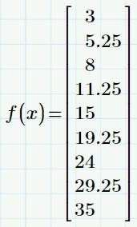

# CHAPTER 7 – CONTROLLING CALCULATIONS

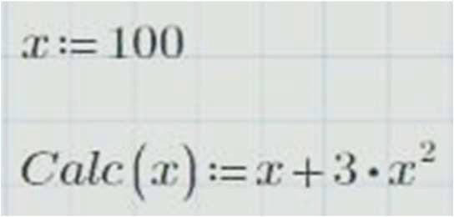

By default, Mathcad opens in Auto Calculation mode. In this mode, all results are automatically updated. When Mathcad is in Auto Calculation mode, a green circle appears in the message line on the lower-left corner of the window.

The numerical results and graphs you see in your window are always up-to-date when in Auto Disabled Regions Calculation mode. If your worksheet contains several computationally intensive equations, scrolling through the worksheet becomes time consuming as Mathcad updates all calculations as you scroll.

You can control calculation updates and calculations in Mathcad by:

* Disabling and enabling Auto Calculation mode.
* Disabling and re-enabling a specific region or group of regions to prevent their evaluation.

If you have disabled a region, or group of regions, the following rules apply:

* You can edit the disabled region but the result is not recalculated, and any regions that depend on the disabled region are not affected.
* The disabled regions are not affected by changes to other regions.

## TO DISABLE AUTOMATIC CALCULATION MODE.

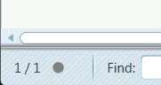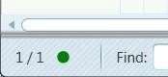

* Select the Calculation tab.
* In the Controls group, click Stop All Calculations
* This de-selects Auto Calculation in the Controls group. A gray circle now appears in the message line on the lower-left corner of the window.
* To re-enable Auto Calculation mode, select the Calculation tab.
* In the Controlsgroup, click Auto Calculation.
* A green circle now appears in the message line on the lower-left corner of the window.

## TO DISABLE MATH REGIONs

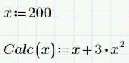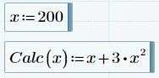

* Create expression for the variable, X, and the function Calc(x), shown.
* Select both regions as shown
* Disable the regions.
  + Select the Calculation tab.
  + In the Controls group, click
  + Disable Region.

**Note:** Mathcad dims the regions to indicate that the regions are disabled.

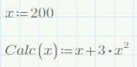

## TO RE-ENABLE MATH REGIONS.

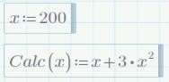

* Select both disabled regions as shown
* Re-enable the regions
* Select the Calculation tab
* In the control group click Disable region

## USING CALCULATION OPTIONS

Mathcad provides calculation options that can be used when evaluating mathematical expressions.

The following calculation options are available:

* Approximate Equality – This option controls the standard used in Boolean expressions and truncation functions. When this option is selected:
  + Two numbers must differ by less than the maximum accuracy of your computer’s floating point processor to be considered equal.
  + Numbers from –10-307 to 10-307 are considered to be zero.
  + All decimal places are used in determining the floor, ceiling, or truncated value of a number.
* ORIGIN in Strings – This option controls the integer associated with the first character in a string. String functions consider the worksheet value for ORIGIN to be the index of the first character when this option is selected.
* Strict Singularity Check – This option controls the matrix inversion algorithm used by Mathcad. If this option is selected, Mathcad checks whether the input matrix or the inverted matrix is singular or ill-conditioned.
* Multithreading – Enables multiple calculations to run in parallel. Speeds up processing of large data sets and matrices.
* Units/Constants in Symbolics – Controls automatic labeling of certain variables as built-in units and constants in symbolics.

You can access these options by selecting the Calculation tab. In the Worksheet Settings group, click and select the required option.

## USING AREAS

Figure: Inserted area

Calculations in Mathcad can be enclosed in an area and collapsed and/or disabled. To enclose calculation in an area

* Insert an area.
* Type calculations in the area.

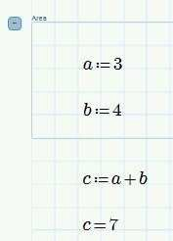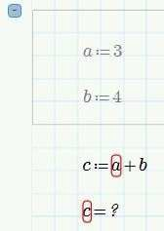

Figure: Enabled regions Figure: Disabled regions

## TO INSERT AN AREA

* Click in a blank area of worksheet
* Select the Document tab
* In the regions group click Area, a bounded area appears as shown.

## TO COLLAPSE AND PROTECT THE AREA

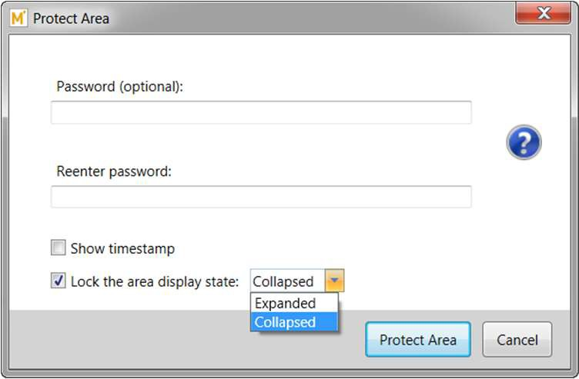

* Click inside the area inserted in the Task 1
* Right click and select Collapse area, the collapsed area appears as shown
* Select the collapsed area.
* Right-click and select Protect Area. Protecting the area protects the calculations within the area from other users changing the content.
* The Protect Area dialog box appears. Complete the following fields:
  + Type a password in the Password field, if desired, and re-enter the password to confirm. These are not required fields. Setting a password for a protected area is optional.
  + Select Show timestamp if you want a date and timestamp displayed on the protected area.
  + Select lock the area display state: and select Expanded or Collapsed from the drop-down list. This locks the display state of the area. If Collapsed is selected, a third party cannot view what is in the area. Any calculations in the area will still remain part of the overall worksheet calculations
* Click Protect Area.

## TO UNPROTECT AND EXPAND THE AREA.

* Select the protected area.
* Right-click and select Unprotect Area.
* The Unprotect Area dialog box appears. Click Unprotect Area.
* To expand the area, select the area.
* Right click and select Expand area

## TO DELETE THE AREA.

* Select the area.
* Right-click in the selected area and select Delete.

# CHAPTER 8 – VECTORS AND MATRICES

A variable can be comprised of a group of data in the form of a vector or matrix.

You can insert an array in Mathcad by:

* Manual entry.
* Defining each element using a range variable.
* Reading in the array directly from a file.

Note: The terms array and matrix are synonymous in Mathcad. A vector is an array containing a single column.

The row and column index starting point default for the array elements is a built- in variable in Mathcad. This variable is named ORIGIN and by default is set to 0. You can globally set this variable by selecting the Calculation tab. In the Worksheet Settings group, select 0 or 1 from the ORIGIN drop-down list. You can also set this variable locally or globally using a definition in the worksheet

**Warning:** *IMPORTANT!* For the examples used in this, the array ORIGIN is equal to 1.

### Range Variables and Vectors:

An Important Distinction. A range variable and a vector may look similar, but they are two distinct quantities and Mathcad treats them differently.

Some differences to consider:

* A range variable is evaluated as a sequence of values, one at a time. A vector or matrix evaluates all values simultaneously.
* It is not possible to extract a single element from a range. It is always possible to extract a single element from a vector or matrix.
* A range variable is used to iterate evaluations or definitions. A vector or matrix is used to store and access information.

## TO GLOBALLY CHANGE THE ARRAY ORIGIN.

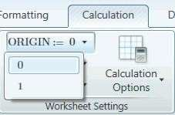

* Select the Calculation tab
* In the worksheet setting group select 0 or 1 from the ORIGIN dropdown list.

**Note:** The ORIGIN is set to 0 by default

## TO LOCALLY CHANGE THE ARRAY ORIGIN.



* Type the word ORIGIN (all capital letters) in the worksheet and insert the Difinitior operator

**Note:** You can insert all operators by selecting the Math tab, clicking Operators, and selecting the desired operator

* Type the desired array ORIGIN in the placeholder and click outside the region. **Note:** This reassigns the array ORIGIN from the insertion point to the end of the worksheet

## DEFINING VECTORS AND MATRICES

You can define a vector or matrix in Mathcad using various methods:

* Manual entry by selecting the Matrices/Tables tab. In the Matrices and Tables group, click Insert Matrix and select the number of elements required.

– You can insert a matrix containing up to 144 elements using this method.

* Populating a matrix element-by-element by defining each element in the array

– To populate an array using this method, you must use a matrix subscript to identify each element. You can locate the Matrix Index operator by selecting the Matrices/Tables tab. In the Matrices and Tables group, click Vector and Matrix Operators and select the Matrix Index operator

* Populating a matrix using range variables.

Here the definition process is automated by using an iterative variable: a range variable representing the index.

Each value in the matrix may be one of the following:

* A scalar.
* A string.
* An array.
* A variable or function that evaluates to a scalar, string, or array.

## TO DEFINE A VECTOR OR MATRIX MANUALLY.



* Type the variable name Matrix and insert the Definition operator. Do not remove your cursor from the math region.

**Note:** You can insert all operators by selecting the Math tab, clicking Operators, and selecting the desired operator.

* Insert the matrix.
  + Select the Matrices/Tables tab.
  + In the Matrices and Tables group, click Insert Matrix.
  + Click and drag to select a 3x3 matrix.
* A matrix with three rows and three columns appears. Each element is represented by a placeholder.
* 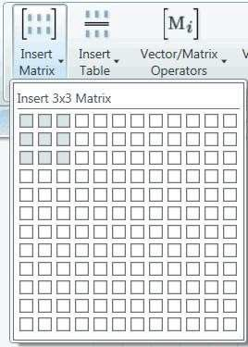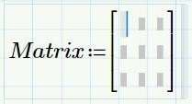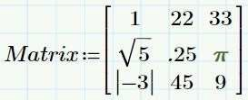Type the values shown in the placeholders. To navigate between placeholders, use the mouse, use the arrow keys, or press TAB.

## TO DEFINE A VECTOR OR MATRIX ELEMENT-BY-ELEMENT

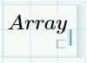

* Type the variable name Array in the worksheet.
* Insert the Matrix Index operator.

**Note:** You can also insert the Matrix Index operator by selecting the Matrices/Tables tab, clicking Vector and Matrix Operators, and selecting the desired operator.

* Type the subscript number of the element in the placeholder as shown.

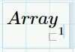

* Insert the Definition operator

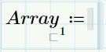

* Type 10 in the placeholder.
* Repeat for each element in the array.

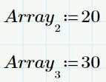

* Evaluate the array by typing Array and inserting the Evaluation operator.

**Note:** You can also define a matrix using this procedure. The subscript notation used is in the form row, column.

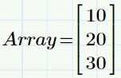

### TO DEFINE A VECTOR OR MATRIX USING RANGE VARIABLES.



* Define a range variable to represent the index of the vector

**Note:** The following are some important guidelines.

* + The range variable for the index usually begins at the origin.
  + The subscript value must be integer valued and take unit steps most of the time.
* Using the definition statement shown, define the elements in the vector.

**Note:** The elements of the array may depend on the range variable.

* Evaluate the vector by typing the vector name vector1 and inserting the Evaluation operator.

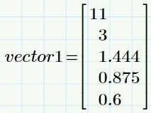

## EXTRACTING ELEMENTS FROM AN ARRAY

You can extract elements from arrays and use them in functions and definition statements.

There are three basic types of data that you can extract from a matrix or array:

* A single element.
* An entire column or row.
* A subset, or submatrix of data.

You can use the built-in submatrix function to extract a subset of data from an array. The submatrix function returns the data in a matrix consisting of the specified number of rows and columns.

## TO EXTRACT A SINGLE ELEMENT FROM AN ARRAY.

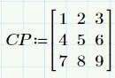

* Define the matrix CP as shown.
* Type the matrix name, CP, and insert the Matrix Index operator.

Note: You can insert matrix operators using one of the following methods:

* + Select the Math tab, click Operators , and select the required operator.
  + Select the Matrices/Tables tab, click Vector and Matrix Operators, and select the required operator.
  + Type the shortcut for the required operator



* Type the row and column indexes shown, separated by a comma, in the index placeholder.

**Note:** Vectors require a single subscript containing the row index

* Insert the evaluation operator.



## TO EXTRACT A COLUMN FROM AN ARRAY

* Type the matrix name, CP, insert the Matrix Column operator.



* Type the column index, 2, in the index placeholder.



* Insert the Evaluation operator.

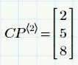

## TO EXTRACT A ROW FROM AN ARRAY.

* Type the matrix name, CP, and insert the Matrix Row Operator.



* Type the row index, 2, in the index placeholder.



* Insert the Evaluation operator



## TO EXTRACT A SUBSET OF DATA FROM AN ARRAY.

* Type the variable name, CPSUB, to which you want to assign the extracted data, and insert the Definition operator.



* Insert the submatrix function.



* + Select the Matrices/Tables tab.
  + In the Matrices and Tables group, click Vector and Matrix Functions .
  + Select submatrix.

**Note:** You can also type in the submatrix function or insert it from the Functions tab.

* The submatrix function displays in the worksheet. Complete the arguments as shown. Do not click outside of the math region.

The arguments required for the submatrix function are:

* The name of the array that contains the data to extract.
* The row to start extracting data.
* The row to stop extracting data.
* The column to start extracting data.
* The column to stop extracting data.
* Insert the Evaluation operator to evaluate the extracted data

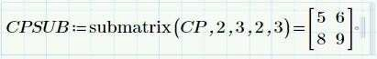

## NESTED ARRAYS

An array embedded within another array is called a nested array.

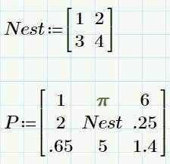

Figure: Nested array

## TO DISPLAY NESTED ARRAY ELEMENTS BY EXTRACTING THE ARRAY.

* Define the two matrices shown. The matrix Nest is nested in the matrix P

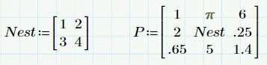

* Type the matrix name, P, and insert the Matrix Index operator.



* In the placeholder, type the row and column location of the nested array, 2,2.



* Insert the Evaluation operator



## TO DISPLAY NESTED ARRAY ELEMENTS BY SPECIFYING THE RESULT FORMAT.

* Evaluate the parent array P as shown

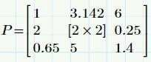

* Select the evaluated matrix P. To expand the nested matrix:
  + Select the Matrices/Tables tab.
  + 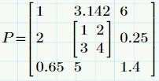In the Result Format section, click Collapse Nested Matrices to de-select it.
* This completes the procedure.

## TO USE THE VECTORIZATION OPERATOR.

* Define the function, F1(b), and matrix, b, shown.

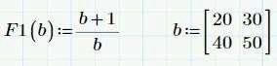

* Type the function name and arguments, F1(b), as shown. Press SPACEBAR until the entire function name highlights.
* Insert the Vectorization
  + Select the Matrices/Tables tab.
  + In the Matrices and Tables group, click Vector and Matrix Operators
  + Select Vectorization



**Note:** You can also insert the Vectorization operator by one of the following methods:

* Selecting the Math tab, clicking Operators and selecting the Vectorization
* Pressing CTRL ^ .
* Evaluate the function or operator by inserting the Evaluation operator.



# CHAPTER 9 – UNITS

## SELECTING A UNIT SYSTEM

Mathcad currently supports three systems of units.

The SI system is the default unit system for Mathcad. Mathcad also supports the following unit systems:

* CGS
* USCS

To select a default unit system.

* Select the Math tab.
* In the Units group, click Unit System.
* Select the default unit system SI from the drop-down list.

**Note:** When you change the default unit system, Mathcad converts all of the evaluated values that have a unit into the new base unit Definition do not change.

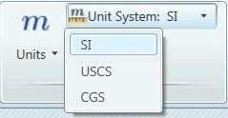

## TO ADD UNITS TO VARIABLE DEFINITIONS.

* Click in a blank area in the worksheet and type the variable name mass
* Insert the Definition operator.
  + Select the Math tab
  + In the Operators and Symbols group, click Operators.
  + Select Definition

**Note:** You can insert operators by selecting the Math tab, clicking the appropriate group, and selecting the desired operator or symbol.

* Type 40 in the placeholder and insert the Multiplication operator.

**Note:** Mathcad does not require the multiplication operator when using units. You can use implied multiplication.



* Insert the kg unit.
  + In the units group, click Units
  + Select the kg unit.

**Note:** You can also type a unit directly in the worksheet.



## TO CHANGE UNITS

* Evaluate the variable mass defined in the previous task.



* Click to the right of the equation press BACKSPACE until the kg unit is deleted.



* Type **lb.** or insert the **lb.** unit from the Units group.
* Click outside of the region.
* Mathcad rescales and redisplays the result. This result is now locked and will not be rescaled if the unit system changes.

**Note:** The abbreviation **lb**. refers to pound mass, while **lbf** is the abbreviation for pound force.



## TO DEFINE A CUSTOM UNIT.

* Click in a blank area of the worksheet and type the unit variable name cfs.
* Insert the Definition operator.

Note: A custom unit can also be defined globally by inserting the Global Definition operator.



* Type the custom unit definition as shown and click outside of the region. The custom unit must contain one of the Mathcad’s built-in units.
* 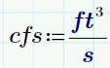In the definition expression you have just typed, you have just typed, select the variable name cfs.
* In the ribbon, select the Math tab.
* Click Labels from the style group.
* Select Unit from the drop down list

**Note:** You can use a custom unit to the right or below where it is defined in the worksheet to rescale results.

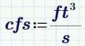

## TO ADD UNITS TO AN ENTIRE ARRAY.

* Click in a blank area of the worksheet and type the variable name Shear.



* Insert the Definition operator.
  + Select the Math tab.
  + In the Operators and Symbols group, click Operators.
  + Select Definition.

Note: You can insert operators by selecting the Math tab, clicking Operators, and selecting the desired operator

* Insert a 5x1 matrix in the placeholder.

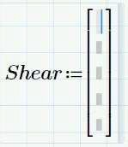

* + Select the Matrices/Tables tab.
  + In the Matrices and Tables group, click Insert Matrix.
  + Click the cursor and drag to highlight a 5x1 matrix and release. A 5x1 matrix of blank placeholders appears in the original placeholder for the variable.
* Type the numbers shown in the placeholders. Press SPACEBAR to highlight the entire matrix.

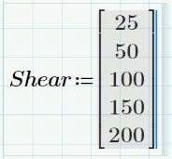

* Insert the Multiplication
* 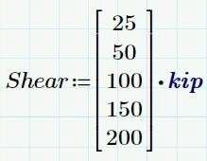Type **kip** in the placeholder, or insert it by selecting the Math tab, clicking Units selecting kip.

## TO ADD UNITS TO EACH ELEMENT OF AN ARRAY.

* Insert a 5x1 matrix shear1 as shown.

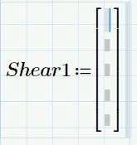

* In each placeholder, type each matrix element and multiply by the unit shown. Note: Elements of an array can be from different systems. Mathcad also supports arrays with mixed dimensions.

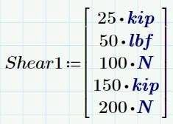

## TO ADD UNITS TO A RANGE VARIABLE.

* Type the variable name Press and insert the Definition operator.
* Complete the following:
  + Type 1 and insert a Multiplication operator.
  + Type psi in the placeholder.
  + Press COMMA Two placeholders and the range variable operator appear.
  + In the first placeholder, type 2 and insert a Multiplication operator.
  + Type psi in the placeholder.
  + In the second placeholder, type 5 and insert a Multiplication operator.
  + Type psi in the placeholder.



* To evaluate the range variable, type the variable name Press and press =.

**Note:** The variable is evaluated in the default units for the worksheet. You can then change these to the desired unit, as shown

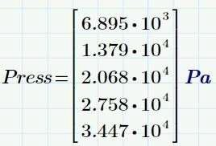

## USING ANGULAR UNITS

Mathcad assumes that values provided for functions requiring an angular argument are in radians.

You must specify degrees when using them in Mathcad.

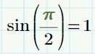

Figure: Default angular units. Figure: Using Degrees.

## TO DEFINE VARIABLES USING DEGREES CELSIUS OR FAHRENHEIT.

* In a blank area of the worksheet, type the variable name Temp.
* Insert the Definition operator.
  + Select the Math tab.
  + In the Operators and Symbols group, click Operators.
  + Select Definition.

**Note:** You can insert operators by selecting the Math tab, clicking Operators, and selecting the desired operator.



* Type 45 in the placeholder.
* Insert a Fahrenheit temperature unit.
  + Select the Math tab.
  + In the Units group, click Units.
  + Select °F.

**Note:** You can insert units by selecting the Math tab, clicking Units, and selecting the desired unit.

* Use implied multiplication when defining units.

**Note:** You can insert a degrees Celsius temperature unit using the same method.



## TO RESCALE TEMPERATURES TO DEGREES CELSIUS OR FAHRENHEIT FROM DEGREES KELVIN OR RANKINE.

* Define and evaluate using kelvin as shown.

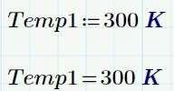

* Click the math region containing the temperature evaluation to the right of the K.
* Press BACKSPACE until the K is deleted.



* Insert a Fahrenheit temperature unit and click outside of the region to evaluate.



## TO EVALUATE TEMPERATURE DIFFERENCES.

* Type 10 and insert a Fahrenheit temperature unit as shown. Press –



* Type 10 and insert a Multiplication operator.



* Insert a change °F temperature unit. Press =.



* Click to the right of the K and press BACKSPACE until the K is deleted. Insert a °F temperature unit.
* Click outside of the region to evaluate.



# CHAPTER 10 – 2 - D PLOTTING

### PLOTTING DATA IN 2-D

You can plot data stored in vectors on 2-D plots. They are plotted as a line plot by default. A simple legend is shown along the vertical Axes limits are automatically selected based on the properties of the data set. Both axes are automatically partitioned and numbered.

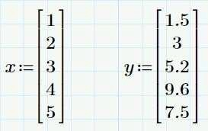 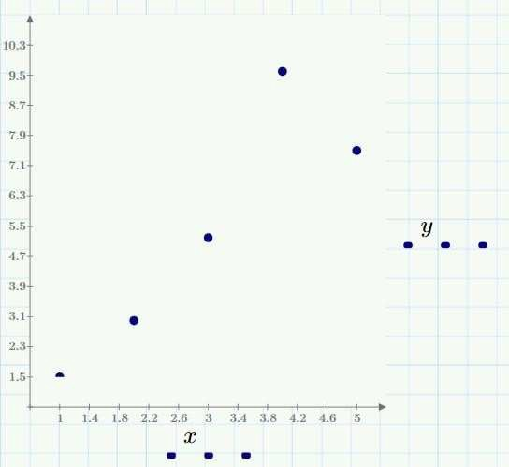

Figure: Data Set Figure: 2-D Plot

## TO PLOT DATA ON A 2-D GRAPH.

* Create two vectors of data, x and y, as shown.

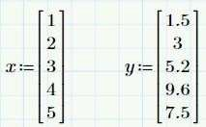

* Insert a plot region.
  + Select the Plots tab.
  + In the Traces group, click Insert Plot
  + Select XY Plot. A blank plot region appears.

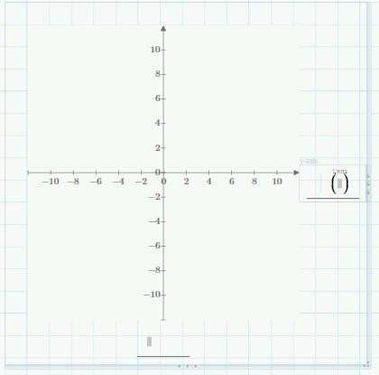

* 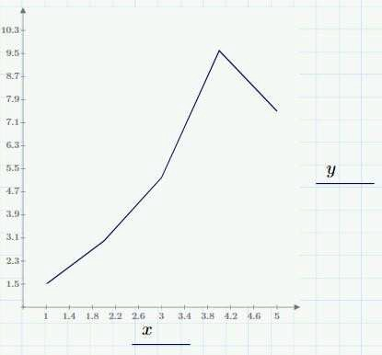Type y in the y-axis placeholder, and type x in the x-axis placeholder as shown. Click outside of the plot region to display the plot.

## TO FORMAT THE PLOT TO DISPLAY INDIVIDUAL DATA POINTS.

* Click y to select the trace.

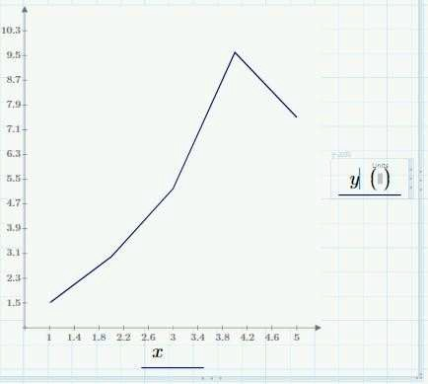

* Display the data as points.
  + Select the Plots tab.
  + In the Styles group, click Symbol, Select x.
  + In the Styles group, click Line Style
  + Select (none). The data displays as data points.

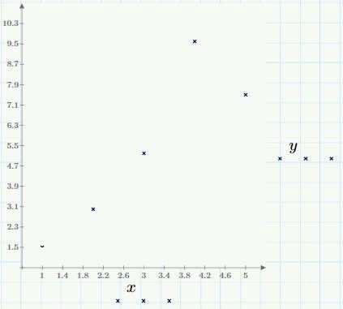

## PLOTTING FUNCTIONS IN 2-D

To Plot a function using a quick plot.

* Define the function shown.



**Note:** When defining the function, select an independent variable that you have not previously used in the worksheet.

* Insert an x-y plot region.
  + Select the Plots tab.
  + In the Traces group, click Insert Plot .
  + Select XY Plot. A blank plot region appears.

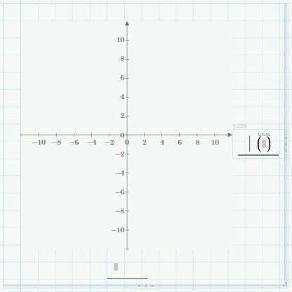

* 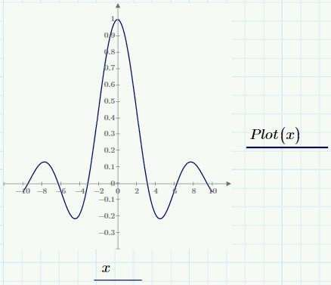Type the function name and arguments, Plot(x), in the vertical axis placeholder. Type the independent variable, x, in the horizontal axis placeholder. Click outside of the plot region to display the plot.

## TO PLOT A FUNCTION USING A DEFINED INDEPENDENT VARIABLE.

* Define the function as shown.



* Define a range variable that specifies the plot domain.



**Note:** For a smooth plot, the second value specified must create a small step.

* 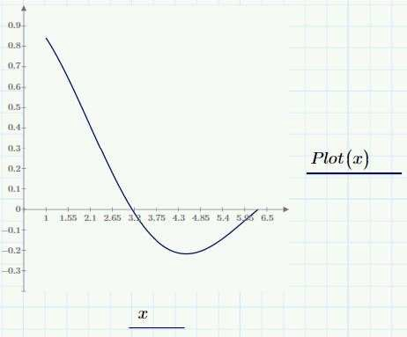Insert a blank x-y plot region. Type the function name and arguments, Plot(x), in the vertical axis placeholder. Type the independent variable, x, in the horizontal axis placeholder. Click outside of the plot region to display the plot.

## TO MANUALLY EDIT THE AXIS LIMITs

* 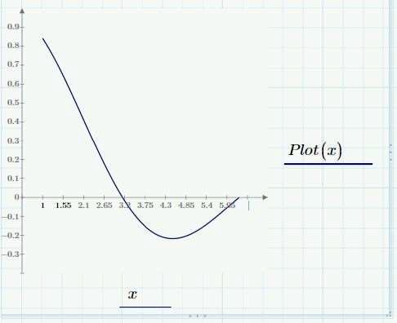Click the 6.5 axis limit and press BACKSPACE until the number deletes, as shown.
* Type a new limit, 5, in the placeholder. Click outside of the plot region to display the plot.

**Note:** You can change the remaining axis limits using the same procedure.

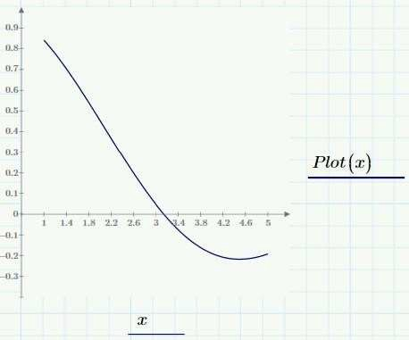

## 2D PLOT FORMATTING

There are many formatting features available for 2-D plots in Mathcad. Features discussed here are:

* Adding vertical markers.
* This feature adds vertical lines to a plot at specified locations.
* Adding horizontal markers.
* This feature adds horizontal lines to a plot at specified locations.

## TO PLOT A FUNCTION USING A QUICKPLOT.

* Define the function shown.

**Note:** When defining the function, select an independent variable that you have not previously used in the worksheet.



* Insert an x-y plot region.
  + Select the Plots tab.
  + In the Traces group, click
  + Insert Plot.
  + Select XY Plot. A blank plot region appears.



* Type the function name and arguments, Plot(x), in the vertical axis placeholder. Type the independent variable, x, in the horizontal axis placeholder. Click outside of the plot region to display the plot.



## TO ADD MARKERS TO THE PLOT

* Double click inside the plot region.
* 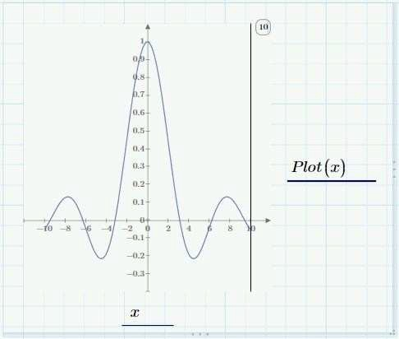Insert a vertical marker. Select the Plots tab. In the Marker group, click Add Vertical Marker. A vertical marker appears on the plot.
* Highlight the number in the callout and press BACKSPACE to delete the number. Type 6 in the callout and click outside of the plot region. The marker moves to the location specified.

**Note:** You can also move the marker by placing the cursor over the marker, The cursor changes to a double-headed arrow. Click the marker and drag it to the desired location.

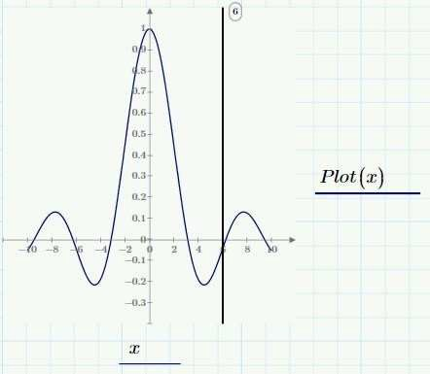

* Click the marker callout to delete the marker. Select the Plots tab In the markers group, click Delete Marker. The marker is deleted.

## 2D TRACE FORMATTING

Mathcad enables you to plot multiple traces on a single plot. Once plotted, you can individually format each trace. Formatting options include:

* + Symbol style
  + Symbol weight
  + Line type
  + Line weight
  + Color
  + Trace type (line, points, bar)
* Define the functions, y1(x) and y2(x) and the independent variable, x, shown.

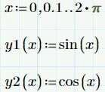

* Insert an x-y plot region.
  + Select the Plots tab.
  + In the Traces group, click Insert Plot.
  + Select XY Plot, A blank plot region appears.

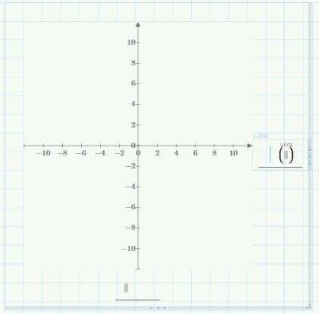

* Type x in the horizontal axis placeholder.

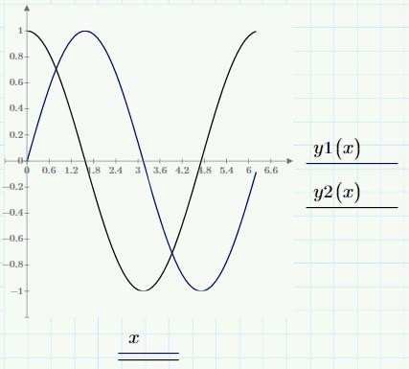

* Add a trace.
  + Click in the vertical axis placeholder.
  + Select the Plots tab.
  + In the Traces group, click Add Trace second vertical axis placeholder appears.
* Type y1(x) in the first vertical axis placeholder and type y2(x) in the second vertical axis placeholder, as shown.

## TO FORMAT A TRACE

* Click in the first vertical axis expression, y1(x). Any formatting selection will be applied to this trace.
* Format the trace.
  + Select the Plots tab
  + In the Styles group, make the following selection: Click Symbol, and select x

Click Line Style, and select (none).

**Note:** You can also modify Trace color and Trace Thickness

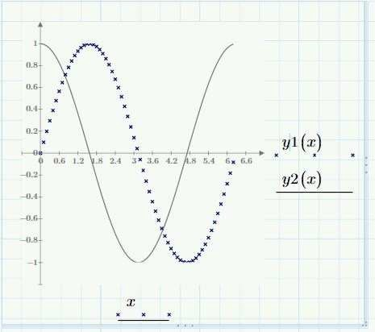

## 2D AXES FORMATTING

Mathcad provides many options to format axes on a 2-D plot. The formatting options available for the 2-D plot axes include:

* Axes Formatting
* Log scale
* Cross axes at 0,0.
* Tick marks – Add or remove tick marks from the axes.
* Tick mark values – Add or remove values from the tick marks on the axes.
* Axis expressions – Add or remove the axes expressions.

Mathcad also provides a feature that enables you to change the displayed format and precision of the axis limits and markings. The options available are:

* General
* Decimal
* Scientific
* Engineering
* Percent

## TO ADD ADDITIONAL TRACES TO A PLOT.

* Define the functions, y1(x) and y2(x), and the independent variable, x, shown.



* Insert an x-y plot region.
  + Select the Plots tab.
  + In the Traces group, click Insert Plot
  + Select XY PlotA blank Plot regions appears.



* Type x in the horizontal axis placeholder
* Add a trace.
  + Click in the vertical axis placeholder.
  + Select the Plots tab.
  + In the Traces group, click Add Trace. A second vertical axis placeholder appears.
* Type y1(x) in the first vertical axis placeholder and type y2(x) in the second vertical axis placeholder, as shown. Click outside of the plot region to display the plot.

## TO EDIT THE TICK MARK VALUE ON THE X-AXIS

* 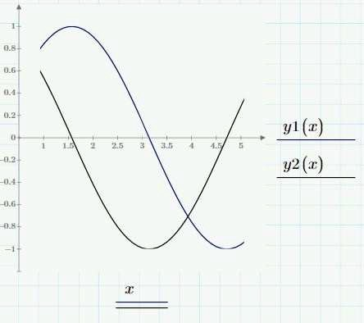You can edit the first, second, and last tick marks. Editing the second tick mark changes the numbering interval for the axis. To edit the tick marks:
  + Click to the right of the 0 on the x-axis. The first, second, and last values on the axis change to black, indicating that you can edit them.
  + Press BACKSPACE to delete the 0 and type 1.0.
  + Repeat for the second and last value. Type 1.5 to replace the second value. Type 5.0 to replace the last value.
  + Click outside of the plot region to display the plot.
* Move the y-axis.
  + Cursor over the y-axis. The cursor changes to a double- headed arrow.
  + Click the cursor and drag it to a new location.

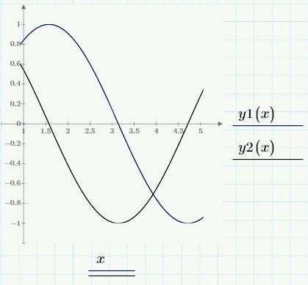

## TO PLOT A 2-D PLOT

* Create the data matrices for Shear, in kip, and Position, in ft, as shown.

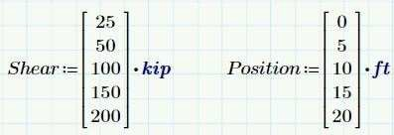

* Insert an x-y plot region.
  + Select the Plots tab.
  + In the Traces group, click Insert Plot .
  + Select XY Plot. A blank x-y plot region appears.
* Type Shear in the y-axis placeholder. Type Position in the x-axis placeholder. Click outside of the plot region.

**Note:** If units are not included in the plot arguments, the data is plotted using default units.

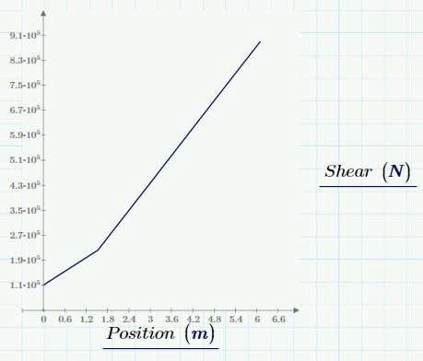

## TO CHANGE THE PLOT UNITS

* Place the cursor to the right of the N in the y-axis placeholder.
* Press BACKSPACE to delete the N. Type kip in the placeholder.
* Place the cursor to the right of the m in the x-axis placeholder.
* 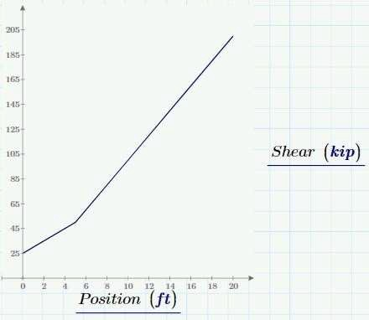Press BACKSPACE to delete the m. Type ft in the placeholder. Click outside of the region.

# CHAPTER 11 – 3-D PLOTTING

You can create 3-D plots from a function of two variables. The following data types can be plotted:

* A function of two variables.
* A vector valued function. Plotting Functions in 3-D
* A function of two variables.
* A vector-valued function. The vector-valued function can have either one or two variables and must contain three elements defining the x, y, and z coordinates.

When you define a function and graph it in three dimensions, you are creating a Quick Plot with a default domain of -10 to 10. Once the function is plotted you can do the following:

* Change the plot domain.
* Change the trace type.
* Check for singularities in the default domain.

Occasionally, the function being plotted has a singularity over the default domain in both independent variables. When this function is plotted as a QuickPlot, Mathcad issues an error message. It is not possible to use range variables to control the domain of the plot. Therefore, the ranges must be modified.

## TO PLOT A FUNCTION IN THREE DIMENSIONS.

* Define the function shown.



* Insert a 3D plot region.
  + Select the Plots tab.
  + In the Traces group, click Insert Plot
  + Select 3D Plot.
  + A blank plot region appears.
* Type the function name S, with no arguments, in the placeholder. Click outside the plot to display the surface plot.

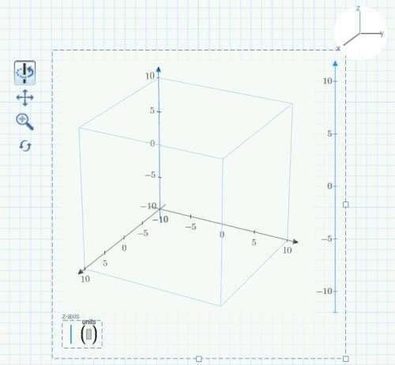

**Note:** A QuickPlot always appears over the default domain of -10 to 10 for both independent variables.

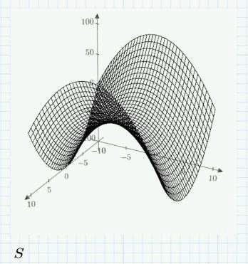

## TO CHANGE THE PLOT DOMAIN.

* Click in the plot region inserted in task 1.



* 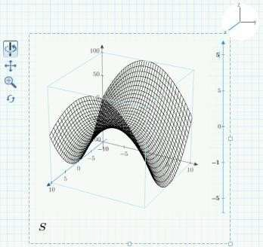Click the x axis in the axis selector. The x axis that appears in both the axis selector and in the plot is highlighted in blue.
* Click the tick mark values and edit them, as shown.

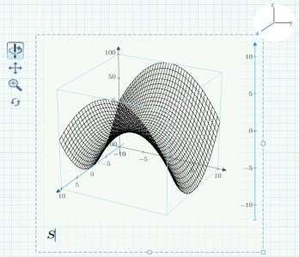

* Click outside the plot to see the modified plot.

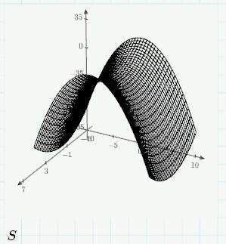

## TO CHANGE THE DEFAULT DOMAIN TO NOT INCLUDE ANY VALUES THAT CAUSE A SINGULARITY IN THE PLOTTED FUNCTION.

* Define the function shown



* Insert a blank 3D plot region and type the function name, Sing, no arguments, in the placeholder. Review the resulting error message.

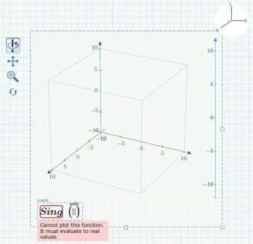

* Click the appropriate axis in the axis selector and modify the x and y axis ranges as follows:

x axis – Range from 2 to 5 y axis – Range from 3 to 5

* Click outside the plot region to view the modified results.

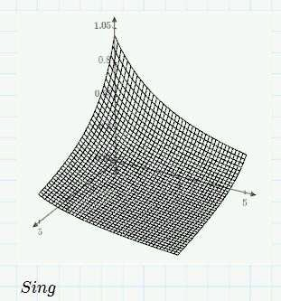

## FORMATTING A 3-D PLOT

Mathcad provides many options for formatting a 3-D plot. 3- D plot formatting options include the following:

* Appearance.
* Axes.
* View Control.
* Suppressing the plot arguments.

### Appearance

Appearance options are located on the Plots tab, in the Styles group. These options enable you to add color to the traces and perform other basic formatting changes. The following options are available:

* Fill options
* Line options
* Symbol options
* Color options

If there is more than one plot in the graph, these options are specific to each plot. You can fill each plot with its own color, lines, and configure other options.

You can also define the grid size per trace in the x and y directions by selecting the number of points in the Traces group.

### Axes

Axes options are located on the Plots tab, in the Axes group, and in the plot region. You can modify the axis tick marks and tick mark values. To modify a specific axis click the axis using the Axis Selector in the upper-right corner of the plot. The Editable Axis, located on the right side of the plot, can then be used to edit the tick mark values.

### View Control

To modify the view and orientation of the plot use the View Control located in the upper-left corner of the plot. The View Control options enable you to spin, pan, zoom, or reset the view of the plot.

### Suppressing the Plot Arguments

To clean up the appearance of a 3-D plot, suppress the display of the plot argument(s) on the bottom of the plot. To toggle the arguments on and off:

* Select the Plots tab.
* In axis group, click Axis Expressions

Suppressing the arguments gives a cleaner look to the plot within the Mathcad document

## TO PLOT A THREE COLUMN MATRIX.

* Define matrix as shown.

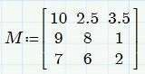

* Insert a 3D plot region.
  + Select the Plots tab.
  + In the Traces group, click Insert Plot
  + Select 3D Plot . A blank plot region appears.



* Type the matrix M in the placeholder. Click outside the plot to display the data plot.
* Review the plot. Note the following:
* Each column in the matrix represents the x, y, and z coordinates. Each row represents one point.
* The points are formatted to appear larger than the default. Click in the plot region and you can format this as follows:

Select the Plots tab.

In the Styles group, click Trace Thickness.

Select the thickness required to display the data points.

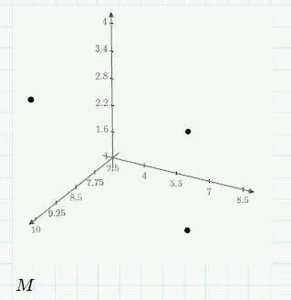

## TO PLOT DATA USING AN M * N MATRIX.

* Define the matrix as shown.
* Insert a 3D plot region.
* Plot the data.
  + Type the matrix name MM in the placeholder. Click outside the plot to display the data plot.
  + To format the plot click in the plot region and select the Plots tab.
  + In the Styles group, click Symbol and select the circular dot.
  + In the Styles group, click Line Styleand select (none).

**Note:** You can increase the trace thickness for better visibility.

* 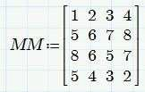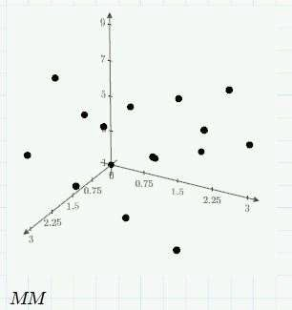Review the plot. Note that each point is plotted as an elevation in the z-axis versus its respective row, x-axis, and column, y- axis, index.

## PLOTTING MULTIPLE TRACES

You can plot multiple traces on a single plot, or add traces to an existing plot. By default, the second trace appears as the same type as the first. You can then modify each plot to the appropriate type.

## TO PLOT MULTIPLE TRACES ON A SINGLE PLOT.

* Define the function as shown.

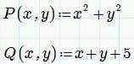

* Insert a 3D plot region.
* Type the function name, P, with no arguments, in the placeholder.
* Add a second trace.
  + Select the Plots tab.
  + In the Traces group, click Add Trace. A second placeholder appears.
  + Type the function name, Q with no arguments, in the placeholder. Click outside the plot to display the surface plots.

**Note:** A Quickplot always appears over the default of -10 to 10 for both independent variables.

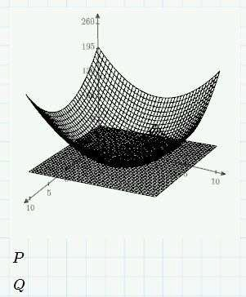

## TO FORMAT THE TRACES

* Change the plot to symbols for the first trace.
  + Click in the plot region and select the first trace, P.
  + Select the Plots tab.
  + In the Styles group, click Symbol and select the dot symbol.
  + In the Styles group, click Line Style and select (none).
* Change the color of the second trace.
  + Select the second trace, Q in the plot region.
  + Select the Plots tab.
  + In the Styles group, click Trace Color and select red.
* Click outside the plot region to display the plot.

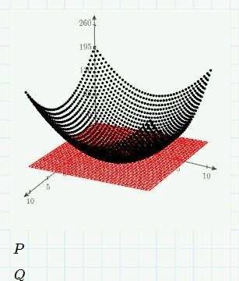

# CHAPTER 12 - BOOLEAN CONDITIONS

## USING BOOLEAN OPERATORS

You can use Boolean operators to evaluate Boolean expressions and specify constraints in solve blocks. You can locate Boolean operators by selecting the Math tab and clicking Operators from the Operators and Symbols group.

You can use them to:

* Write equations used in solving systems of equations.
* Create conditional statements.
* Document equations which do not need to be evaluated.

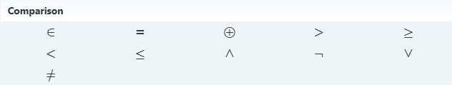

Figure: Boolean Operators

### Writing equations using Boolean operators



All equations used inside a solving construct must use Boolean operators.

The Equal To operator is the most commonly used Boolean operator when solving a system of equations.



### Creating Conditional Statements

Boolean operators, unlike other operators, can return a zero or one. Mathcad returns the following results for a conditional statement:

* If the expression using the Boolean operator is true, the Boolean operator returns a one.
* If the expression using the Boolean operator is false, the Boolean
* If the expression using the Boolean operator is false, the Boolean operators return a zero.

### Using Piecewise Continuous Functions

A function that is not uniform over its range is known as a Piecewise function.

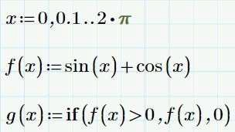

## TO CREATE PIECEWISE CONTINUOUS FUNCTIONS USING BOOLEAN OPERATORS:

* Define a range of values over which the function
* Define the function using Boolean operators.
* Graph the function to validate the results.

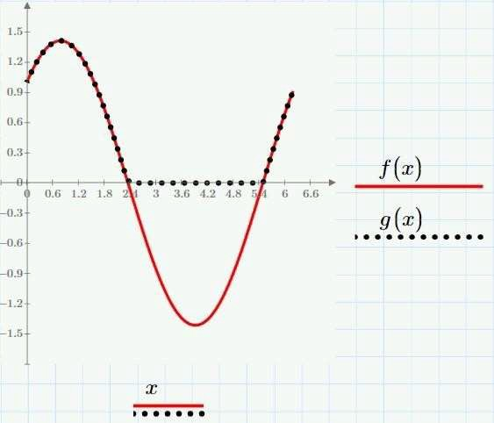

## TO DEFINE THE RANGE AND FUNCTION TO USE IN THE PIECEWISE CONTINUOUS FUNCTION.

* Define the range shown, over which you will evaluate the function.

Note: You can insert operators or constants by selecting the Math tab. In the Operators and Symbols group, select the desired operator or constant.



* Define the function shown to use in the Piecewise Continuous function. Note: You can type in or insert functions in the worksheet by selecting the Functions tab. In the Functions group, click All Functions. Expand the appropriate group, and select the desired function.



* Define the Piecewise Continuous function.
  + Type the function name and arguments g(x).
  + Insert the Definition operator.
  + Insert, if function.
    - Select the Functions tab.
    - In the Functions group, click All Functions
    - Expand the Piecewise Continuous group, and select the if function.



* Complete the placeholders as shown.
* Graph the functions f(x) and g(x) to validate.



**Note:** A symbol was selected for the g(x) trace to make identification clearer.

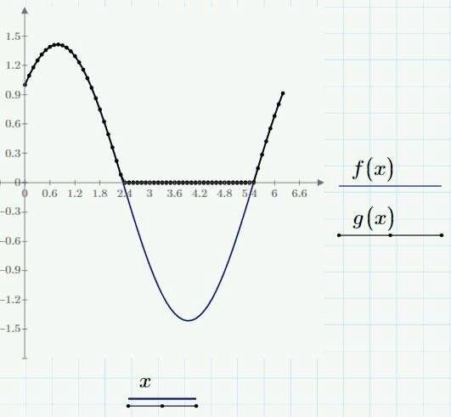

# CHAPTER 13 – SYMBOLICS

Mathcad can perform operations on symbolic expressions, expressions that contain variables or mathematical symbols, and return results in symbolic form.

You can perform symbolic calculations on:

* Variables
* Functions

Symbolic calculations can return results in terms of:

* Floating point numbers.
* 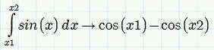Undefined variables and functions.

## TO EVALUATE A RESULT SYMBOLICALLY.

* Type the expression to be evaluated symbolically, as shown.

Note: You can symbolically evaluate expressions that have variables not assigned to numeric values.

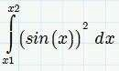

* Position the cursor to the right of the expression, as shown. Insert the Symbolic Evaluation operator.
  + Select the Math tab.
  + In the Operators and Symbols group, click Symbolics.
  + Select Symbolic Evaluation.

**Note:** The Symbolic Evaluation operator can also be inserted by selecting the Math tab. In the Operators and Symbols group, click Operators and select Symbolic Evaluation.

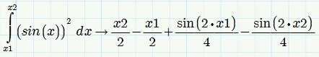

* Click outside the region.

## SYMBOLIC ALGEBRA

You can use the following keywords to algebraically simplify, expand, or factor expressions.

* **Simplify** – Simplifies an expression by performing arithmetic, cancelling common factors, and using basic trignometric and inverse function identities.
* **Expand** – Expands all powers and products of sums in an expression.
* **Factor** – Factors an expression into a product, if the entire expression can be written as a product.

# CHAPTER 14 – SOLVING

## SOLVING FOR ROOTS OF ROOT EQUATIONS

Mathcad enables you to numerically solve for the roots of functions of single independent variables. Mathcad offers two built-in functions to numerically locate the roots of functions of single independent variables:

* The root function.
* The polyroots function.

### The Root Function

You can use the root function for all types of functions. You can use it in two formats:

* A two-argument case, which uses a guess value to search for the root
* A four-argument case, which uses a range over which to search for the root. The root function, two-argument case, has the format:

### root (f(t), t)

Where:

**f (t)** is the function.

**t** is the guess value for the root of the function. The root function, four-argument case, has the format: **root (f(t),t, A, B)**

Where:

**f(t)** is the function.

**t** is the independent variable of the function.

**A** and **B** define the interval in which Mathcad searches for the root.

No guess values are required for this format. The values of the function at each endpoint of the range must be of opposite sign. This ensures that there is a root in the range. You can evaluate multiple roots of a function by giving different boundary conditions.

## THE POLYROOTS FUNCTION

The polyroots function finds all the roots of a polynomial function. The polyroots function has the format:

### Polyroots (v)

Where:

**V** is a vector containing the coefficients of the polynomial.

## THE SYMBOLIC ROOT FUNCTION

Mathcad provides the ability to solve for roots symbolically by selecting the Math tab. In the Operators and Symbols group click Symbolic and click the solve keyword.

The following apply when solving for roots symbolically:

* Mathcad does not require you to specify “=0” when solving symbolically for roots.
* The roots are returned in a vector.
* No guess value is required.
* Results can include complex values.
* Results can be in terms of other variables.
* The solve keyword is not limited to polynomials.
* If an equation has a periodic solution the solve keyword returns a single value from the set of solutions. To view a detailed solution, add the modifier fully after the keyword solve, separated by a comma.

## TO UTILIZE THE ROOT FUNCTION, TWO-ARGUMENT CASE.

* Type in the function shown below.

**Note:** To insert any operator, select the Math tab, click Operators, and select the operator to insert.



* Assign a guess value for the independent variable of the function.



* Insert the root function.
  + Select the Functions tab.
  + In the Functions group, click Solving.
  + Select root.



* Complete the placeholders as shown.
* Delete the remaining two placeholders.
* Insert the Evaluation operator to evaluate.



## TO UTILIZE THE ROOT FUNCTION, FOUR-ARGUMENT CASE.

* Type in the function shown below.



* Insert the root function.
  + Select the Functions tab.
  + In the Functions group, click Solving.
  + Select root operator to evaluate



* Complete the placeholders as shown.



* Insert the Evaluation operator to evaluate.

**Note:** The values of the function at each endpoint of the range must be of opposite sign. This ensures that there is a root in the range. You can evaluate additional roots using a different range in the function statement.

## TO UTILIZE THE POLYROOTS FUNCTION.

* Type in the function.



* Define the coefficient matrix as shown.

**Note:** To insert a matrix, select the Matrices/Tables tab, click Insert Matrix, and select the desired matrix.

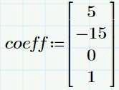

* Insert the polyroots function.
  + Select the Functions tab.
  + In the Functions group, click Solving.
  + Select polyroots.



* Type coeff in the placeholder.
* Insert the evaluation operator to evaluate.

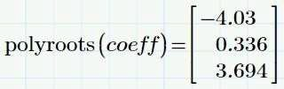

## TO SYMBOLICALLY SOLVE THE ROOTS.

* Type in the function as shown.



* Insert the solve keyword.
  + Select the Math tab
  + In the Operators and Symbols group, click Symbolics.
  + Select solve
* Type x after the solve keyword and click outside the region to evaluate.

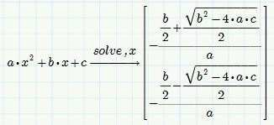

## TO USE THE BUILT-IN LSOLVE FUNCTION TO SOLVE THE SYSTEM OF EQUATIONS.

Numerically solve the following system of linear equations using the built-in solve function and a solve block.

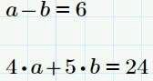

* 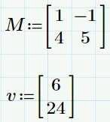Rewrite the system in matrix form, using a coefficient matrix, M, and a column matrix of constants, v.
* Insert the lsolve function.
  + Select the Functions tab.
  + In the Functions group, click Solving.
  + Select lsolve.



* Type the variable names of the coefficient matrix, M, and the column matrix of constants, v, in the placeholders.
* Retroactively assign a matrix containing the unknown variables to the function lsolve and evaluate the results.

**Note:** The Isolve function enables you to use real or complex numbers and supports the use of units.

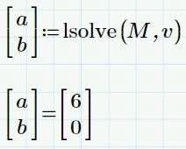

## TO USE A SOLVE BLOCK TO SOLVE THE SYSTEM OF EQUATIONS.

* Define any constant variables and functions in the equation set. Note: This example does not have any constants to define
* Click in a blank area of the worksheet and insert a solve block.
  + Select the Math tab.
  + In the Regions group, click Solve Block. A solve block region appears.

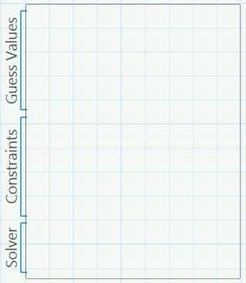

* In the Guess Values section of the solve block, type a guess value for each variable to be solved as shown.

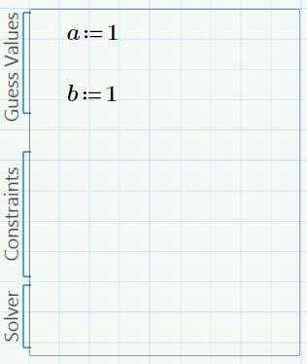

* In the Constraints section of the solve block, define the constraints shown using Boolean operators.

**Note:** You can use the following operators: Equal To

Greater Than

Greater Than or Equal To Less Than

Less Than or Equal To

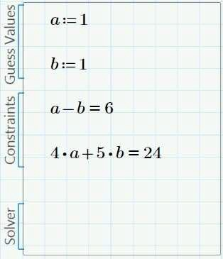

* In the Solver section of the solve block, close the solve block by assigning the unknown variables to the Find built-in function, as shown. The Find built-in function returns a solution that satisfies Mathcad's internal convergence tolerance, defined by the built-in variable TOL.

**Note:** You can also write the solve block in matrix form.

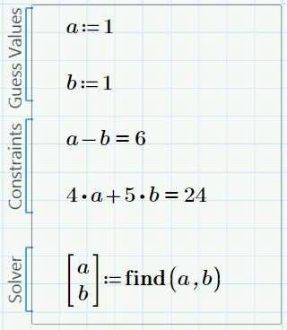

* Evaluate the solution.

**Note:** Your answer may not display exactly zero. This display depends on the Results setting. The Results setting is located in the Results group on the Math Formatting tab.

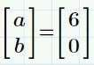

## TO USE A SOLVE BLOCK TO SOLVE THE SYSTEM OF NONLINEAR EQUATIONS.

* Define any constant variables and function in the equation set.

**Note:** This example does not have any constraints to define.

* In the blank area of the worksheet, insert a solve block.
  + Select the Math tab
  + In the Region group, click Solve Block.
  + A blank solve block region appears.
* In the Guess Values section of the solve block, type the guess values, as shown.
* In the constraints section of the solve block, define the constraints shown, using Boolean operators

**Note:** You can use the following operators: Greater Than or Equal To

Less Than or Equal To Equal To

Greater Than Less Than

* Close the solve block by assigning the unknown variables to the built-in function Find.

**Note:** Find returns a solution that satisfies Mathcad's internal convergence tolerance, defined by the built-in variable TOL.

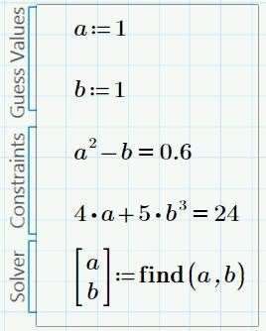

* Evaluate the result.

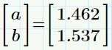

## SYMBOLICALLY SOLVING SYSTEMS OF EQUATIONS

Mathcad enables you to solve a system of linear or nonlinear equations symbolically. To solve a system of equations symbolically, use the solve keyword.

### To solve a system of equations symbolically.

* Insert a 2x1 matrix.



* Type the equations shown in the placeholders.



* Click outside the region to evaluate.



* **Note:** The variables to be solved for, x and y, could also be placed in a 2x1 matrix as shown.

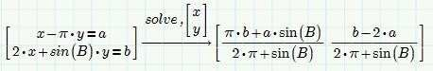

## MODIFYING THE CONVERGENCE AND CONSTRAINT TOLERANCE MATHCAD ENABLES YOU TO CUSTOMIZE A SOLVE BLOCK.

You can customize a solve block by:

* + Modifying the convergence tolrence.
  + Modifying the constraint tolrence

### The Convergence Tolerance

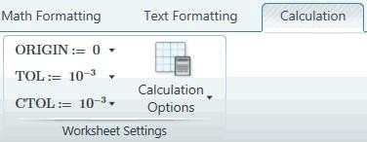

The Find function attempts to return an answer with an error satisfying the built- in convergence tolerance, which is 0.001 by default. Mathcad enables you to change the tolerance as required.

You can globally modify the convergence tolerance by selecting the Calculation tab. In the Worksheet Setting group, click TOL and select the tolerance required. To locally modify the convergence tolerance, define it in the worksheet.

### The Constraint Tolerance

The constraint tolerance, which is 0.001 by default, controls how close a constraint in a solve block must be met. Mathcad enables you to change the tolerance as required.

You can globally modify the convergence tolerance by selecting the Calculation tab. In the Worksheet Setting group, click CTOL and select the tolerance required. To locally modify the constraint tolerance, define it in the worksheet.

Tightening both tolerances may lead to a better solution, but keep in mind that it may also place an unreasonable expectation on the solver and generate an error.

# CHAPTER 15 – PROGRAMMING

## CREATING A PROGRAM

Mathcad's programming operators enable the extension of Mathcad's functionality when writing customized functions and processes for calculations. You can access Mathcad's programming operators by selecting the Math tab, and clicking Programming

## TO START A PROGRAM IN MATHCAD.

* + Type the function name NewProg(a,b) and insert a definition operator.

**Note:** When typing a function name, the arguments are the variables passed to the program from the Mathcad worksheet. You can also use a variable name



* + Insert a programming construct.
    - Select the Math tab.
    - In the Operators and Symbols group, click Programming.
    - Select Program.

**Note:** You can insert programming operators by selecting the Math tab, clicking Programming, and selecting the desired programming operator.

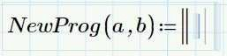

## TO ASSIGN A LOCAL DEFINITION.

* + Click in the top placeholder of the started in the previous task.

**Note:** In each placeholder, you can insert:

* + - A local variable or function definition.
    - A programming operator, such as for loop.



* + Insert a Local Assignment operator. A left pointing arrow with two placeholders appears.
  + Type the expression shown in the right placeholder, and the variable c in the left placeholder.

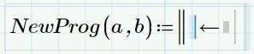

* + The expression, a/10, is now locally assigned to the variable c. Press SPACEBAR until the entire expression highlights.

**Note:** All assignments made using the Local Assignment operator are local to the program and are not recognized outside of the program. Definitions made outside and before the program are not overwritten inside the program.

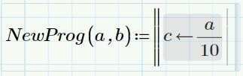

* + Press ENTER. A new line appear with a placeholder.

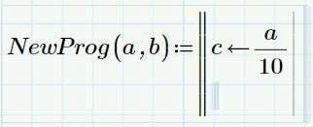

* + Insert a Local Assignment operator and type in the expression shown.

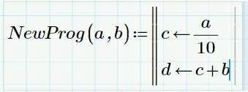

* + Press SPACEBAR until the bottom line highlights. Press ENTER to add a new line.

**Note:** To insert a line below the selected line, place the cursor to the right of the line selected. If it appears to the left of the line selected, Mathcad inserts the line above the selected line

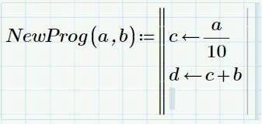

## TO END A PROGRAM IN MATHCAD.

* + Using the modified in the previous task, click in the last placeholder.

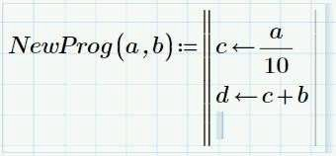

* + The last line of a displays what is returned to the Mathcad worksheet from the program. The last line of the may contain:

A variable.

An expression. A function.

A vector or matrix containing variables or functions as elements.

* + In the placeholder, type the variable d.

**Note:** To return multiple values from a program, place the values in a vector or matrix on the last line of a program.

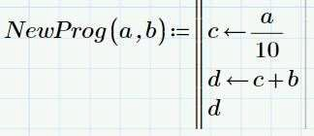

## TO EVALUATE A PROGRAM IN MATHCAD.

* + Define the variables being passed to the program.

**Note:** You can define the variables before orafter the definition, or as part of the program evaluation.

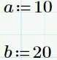

* + Type the name of the program, including the variables in parentheses. Insert the Evaluation operator. Click outside of the region to evaluate.

## CONDITIONAL STATEMENTS

Mathcad provides operators to enable conditional branching. The operators that enable conditional branching are:

* + if
  + else
  + else if
  + also if

You can use conditional statements to execute or skip certain calculations. They use Boolean conditions to direct an execution. The Boolean condition must be a comparison or expression that evaluates to 0 (false) or 1 (true).

The program will accept a number sent to the program. If the number is odd it will return the word True. If the number is even it will return the word False. A built-in function mod (modulus) is used in this program. The function mod divides the first argument of the function by the second argument of the function. The function returns the remainder of this integer division. The remainder has the same sign as the first argument.

Therefore:

mod(x,2) of even numbers is 0. mod(x,2) of positive odd numbers is 1. mod(x,2) of negative odd numbers is -1.

Create this program twice, once using if programming operators and once using a combination of if and else operators.

## TO USE THE IF PROGRAMMING OPERATOR.

* + Type in the name of the program, including argument, IsOdd(x) insert a Definition operator.
  + Click in the placeholder displayed and insert a construct.



* + - Select the Math tab.
    - In the operators and symbols group click Programming if
    - Select program.

**Note:** You can insert programming operators by selecting the Math tab, clicking Programming, and selecting the desired operator.

* + Insert a Local Assignment operator and type in the expression shown.

**Note:** To create the string variable “False,” click in the placeholder and press the double quotation key (“). Type False.

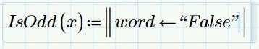

* + 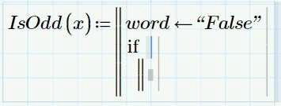Press SPACEBAR until the first expression highlights. Press ENTER to create a new line. Insert, if operator.
  + Type the expressions in the placeholders, as shown.

**Note:** You can type the mod function in the placeholder or insert it by selecting the Function tab. In the Functions group, click All Functions. Expand the Number Theory/Combinatorics category and select mod. You can insert all other operators by selecting the Math tab, clicking Operators and selecting the desired operator. The equal sign (=) is a Boolean operator.

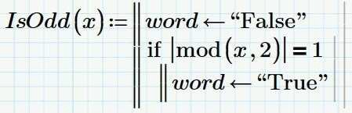

* + Press SPACEBAR until the entire if construct highlights. Press ENTER and type the variable word in the placeholder. The value returned by the program is the variable on the last line of the program. In this case, the last line contains the variable word.

**Note:** To execute multiple statements when the Boolean condition defined by the if statement is true:

* + - Press SPACEBAR until the second line of the if construct highlights.
    - Press ENTER as many times as needed to add additional lines. Mathcad stacks the statements to be executed below the condition.

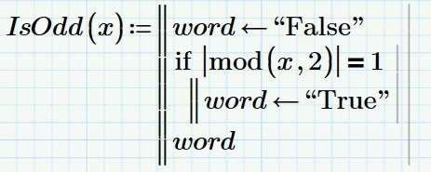

* + Evaluate the program using varying inputs, as shown.

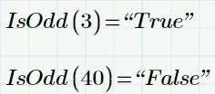

## TO USE THE ELSE PROGRAMMING OPERATOR.

* + Type in the name of the program, including argument, IsOdd(x) and insert a Definition operator.
  + Click in the placeholder displayed and insert a construct.



* + Insert the if operator.

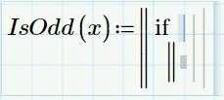

* + Complete the placeholder as shown.

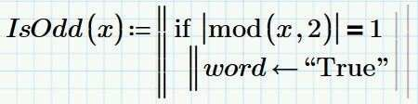

* + Press SPACEBAR until the entire if construct highlights. Press ENTER.

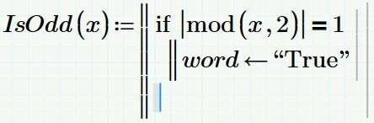

* + Insert the else operator in the placeholder.

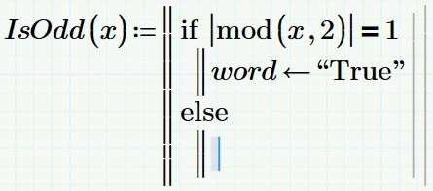

* + Complete the placeholders as shown.

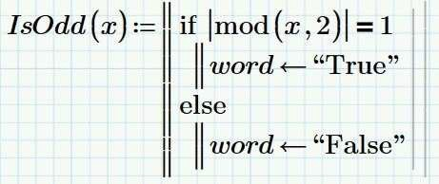

* + Evaluate the using varying inputs, as shown.



* + This completes the procedure.

## LOOPING CONSTRUCTS

Mathcad looping constructs enable you to iterate any combination of expressions in a way that is difficult to execute with range variables or other constructs. Two looping constructs are available:

* + For loops.
  + While loops.

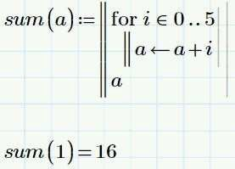 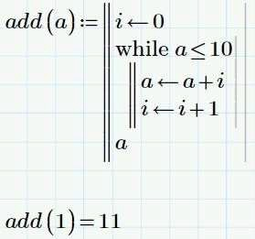

### To Use a for loop to program the Fibonacci series.

* + By definition, the first two numbers in the Fibonacci series are both 1.0. After that each element in the series is the sum of the previous two elements. Set the origin for your worksheet equal to 1.0.
    - Select the Calculation tab.
    - In the worksheet setting group, click ORIGIN
    - Select 1.
  + Type in the definition and the first lines of the program, as shown. You can insert programming operators by selecting the Math tab, clicking Programming if, and selecting the desired operator.

Note: You use the following in the program shown:

* + - The equal signs are comprised of the Equal to operator.
    - The subscripts are comprised of the Matrix Index operator.
    - The word return is a Programming operator.

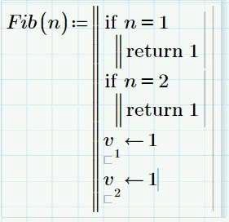

* + 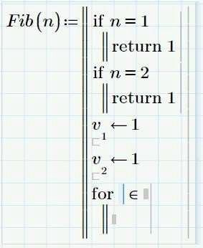Highlight the last line of the program and press ENTER. Click in the placeholder displayed and insert the for operator
  + In the first line of the for loop, type i in the left placeholder. In the right placeholder, type the range 3..n.

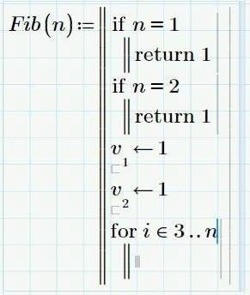

* + In the last line of the for loop, type the expression shown. Select the Matrix Index operator to create the subscripts, Press SPACEBAR to highlight the entire for loop and press ENTER to add the final line.

**Note:** It is necessary to highlight the entire loop otherwise, Mathcad adds a line inside the loop.

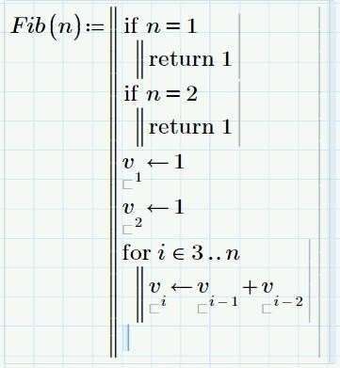

* + 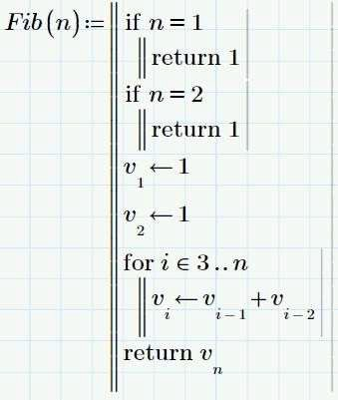Click in the placeholder on the last line of the and insert the return operator. Type v with a subscript of n in the placeholder. Select the Matrix Index operator to create the subscript.
  + Evaluate the program, as shown.



### To Use a while loop to Newton's method for finding the root of a number.

* + Type in the program definition and the first two lines of the program. Add a new line.

**Note:** You can insert math operators by selecting the Math tab, clicking Operators, and selecting the desired operator.

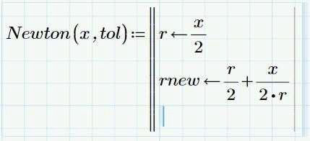

* + Click in the empty placeholder and insert a while operator.

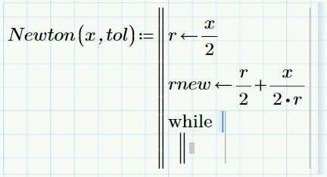

* + 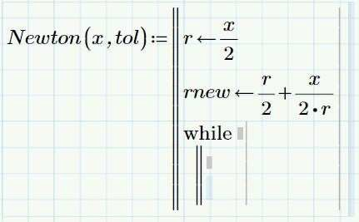Click in the placeholder on the second line of the while loop and press ENTER to add another line to the while loop construct.
  + Type the expressions in the while loop placeholder, as shown. When you finish, press SPACEBAR until the while loop highlights.

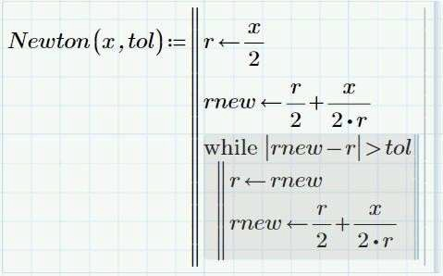

* + 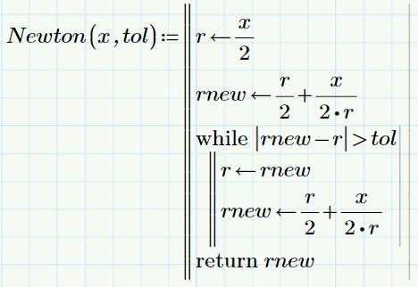Press ENTER to add a new line. Insert the return operator. Type rnew in the placeholder.
  + Evaluate the program as shown.

